LECTURE NOTES

ON

BIG DATA AND BUSINESS ANALYTICS

**2019 – 2020**

# UNIT I INTRODUCTION TO BIG DATA

* 1. **INTRODUCTION TO BIG DATA**

Big Data is becoming one of the most talked about technology trends nowadays. The real challenge with the big organization is to get maximum out of the data already available and predict what kind of data to collect in the future. How to take the existing data and make it meaningful that it provides us accurate insight in the past data is one of the key discussion points in many of the executive meetings in organizations.

With the explosion of the data the challenge has gone to the next level and now a Big Data is becoming the reality in many organizations. The goal of every organization and expert is same to get maximum out of the data, the route and the starting point are different for each organization and expert. As organizations are evaluating and architecting big data solutions they are also learning the ways and opportunities which are related to Big Data.

There is not a single solution to big data as well there is not a single vendor which can claim to know all about Big Data. Big Data is too big a concept and there are many players – different architectures, different vendors and different technology.

The three Vs of Big data are Velocity, Volume and Variety.

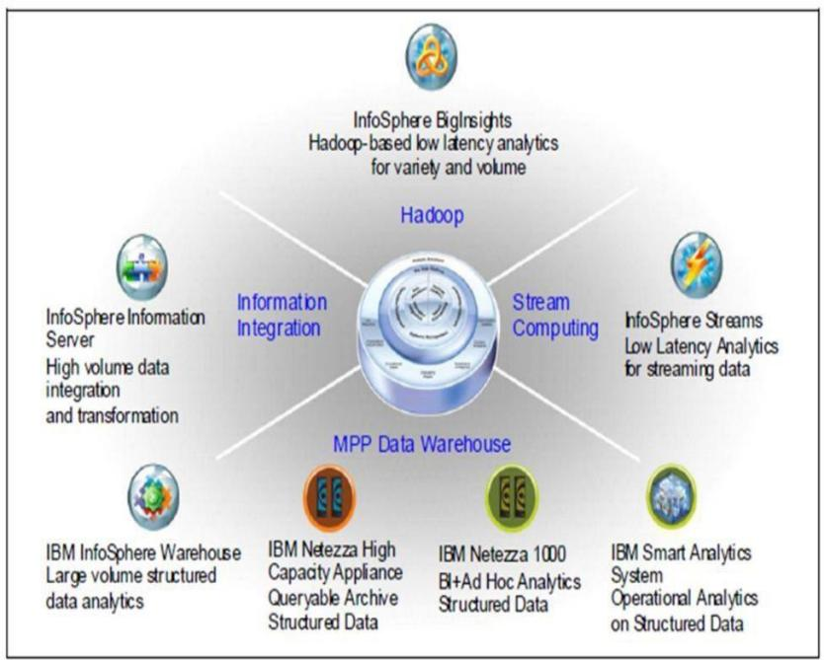

Figure 1.1: Big Data Sphere

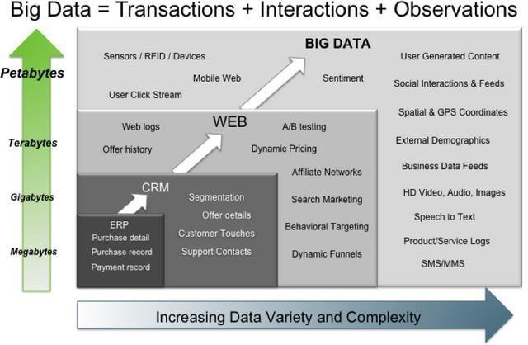

Figure 1.2: Big Data – Transactions, Interactions, Observations

# BIG DATA CHARACTERISTICS

1.The three Vs of Big data are Velocity, Volume and Variety

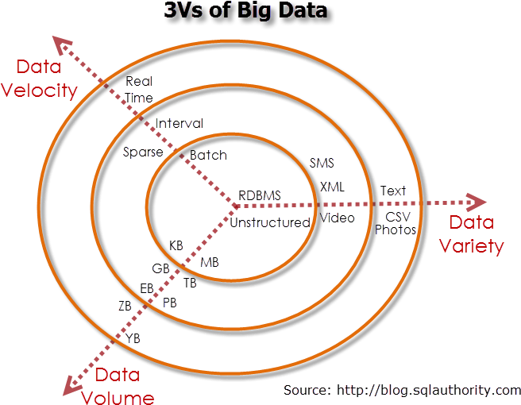

Figure. : Characteristics of Big

# VOLUME

The exponential growth in the data storage as the data is now more than text data. The data can be found in the format of videos, music’s and large images on our social media channels. It is very common to have Terabytes and Petabytes of the storage system for enterprises. As the database grows the applications and architecture built to support the data needs to be re-evaluated quite often.

Sometimes the same data is re-evaluated with multiple angles and even though the original data is the same the new found intelligence creates explosion of the data. The big volume indeed represents Big Data.

# VELOCITY

The data growth and social media explosion have changed how we look at the data. There was a time when we used to believe that data of yesterday is recent. The matter of the fact newspapers is still following that logic. However, news channels and radios have changed how fast we receive the news.

Today, people reply on social media to update them with the latest happening. On social media sometimes a few seconds old messages (a tweet, status updates etc.) is not something interests users.

They often discard old messages and pay attention to recent updates. The data movement is now almost real time and the update window has reduced to fractions of the seconds. This high velocity data represent Big Data.

# VARIETY

Data can be stored in multiple format. For example database, excel, csv, access or for the matter of the fact, it can be stored in a simple text file. Sometimes the data is not even in the traditional format as we assume, it may be in the form of video, SMS, pdf or something we might have not thought about it. It is the need of the organization to arrange it and make it meaningful.

It will be easy to do so if we have data in the same format, however it is not the case most of the time. The real world have data in many different formats and that is the challenge we need to overcome with the Big Data. This variety of the data represent Big Data.

# TYPES OF BIG DATA

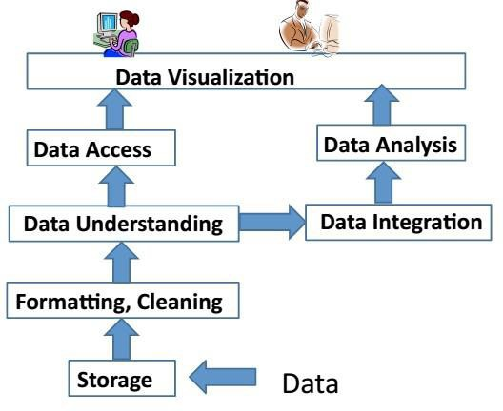

Figure 1.5 : Big Data Layout

# APACHE HADOOP

Apache Hadoop is one of the main supportive element in Big Data technologies. It simplifies the processing of large amount of structured or unstructured data in a cheap manner. Hadoop is an open source project from apache that is continuously improving over the years. "Hadoop is basically a set of software libraries and frameworks to manage and process big amount of data from a single server to thousands of machines.

It provides an efficient and powerful error detection mechanism based on application layer rather than relying upon hardware."

In December 2012 apache releases Hadoop 1.0.0, more information and installation guide can be found at Apache Hadoop Documentation. Hadoop is not a single project but includes a number of other technologies in it.

# MAPREDUCE

MapReduce was introduced by google to create large amount of web search indexes. It is basically a framework to write applications that processes a large amount of structured or unstructured data over the web. MapReduce takes the query and breaks it into parts to run it on multiple nodes. By distributed query processing it makes it easy to maintain large amount of data by dividing the data into several different machines. Hadoop MapReduce is a software framework for easily writing applications to manage large amount of data sets with a highly fault tolerant manner. More tutorials and getting started guide can be found at Apache Documentation.

## HDFS(Hadoop distributed file system)

HDFS is a java based file system that is used to store structured or unstructured data over large clusters of distributed servers. The data stored in HDFS has no restriction or rule to be applied, the data can be either fully unstructured of purely structured. In HDFS the work to make data senseful is done by developer's code only. Hadoop distributed file system provides a highly fault tolerant atmosphere with a deployment on low cost hardware machines. HDFS is now a part of Apache Hadoop project, more information and installation guide can be found at Apache HDFS documentation.

# HIVE

Hive was originally developed by Facebook, now it is made open source for some time. Hive works something like a bridge in between sql and Hadoop, it is basically used to make Sql queries on Hadoop clusters. Apache Hive is basically a data warehouse that provides ad-hoc queries, data summarization and analysis of huge data sets stored in Hadoop compatible file systems.

Hive provides a SQL like called HiveQL query based implementation of huge amount of data stored in Hadoop clusters. In January 2013 apache releases Hive 0.10.0, more information and installation guide can be found at Apache Hive Documentation.

# PIG

Pig was introduced by yahoo and later on it was made fully open source. It also provides a bridge to query data over Hadoop clusters but unlike hive, it implements a script implementation to make Hadoop data access able by developers and business persons. Apache pig provides a high level programming platform for developers to process and analyses Big Data using user defined functions and programming efforts. In January 2013 Apache released Pig 0.10.1 which is defined for use with Hadoop 0.10.1 or later releases. More information and installation guide can be found at Apache Pig Getting Started Documentation.

# TRADITIONAL VS BIG DATA BUSINESS APPROACH

## 1. Schema less and Column oriented Databases (No Sql)

We are using table and row based relational databases over the years, these databases are just fine with online transactions and quick updates. When unstructured and large amount of data comes into the picture we needs some databases without having a hard code schema attachment. There are a number of databases to fit into this category, these databases can store unstructured, semi structured or even fully structured data.

Apart from other benefits the finest thing with schema less databases is that it makes data migration very easy. MongoDB is a very popular and widely used NoSQL database these days. NoSQL and schema less databases are used when the primary concern is to store a huge amount of data and not to maintain relationship between elements. "NoSQL (not only Sql) is a type of databases that does not primarily rely upon schema based structure and does not use Sql for data processing."

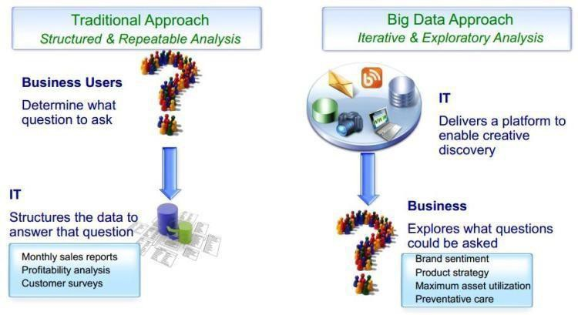

Figur1e. : Big Data

The traditional approach work on the structured data that has a basic layout and the structure provided.

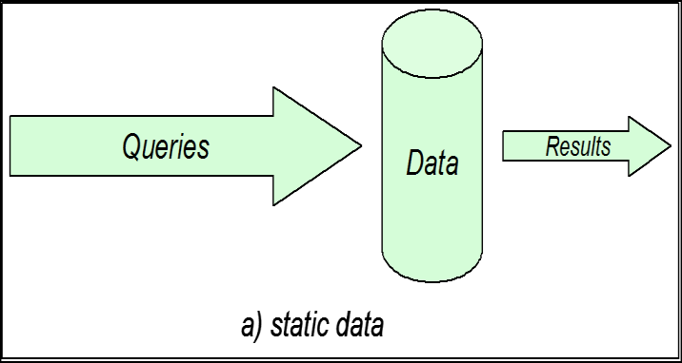

Figure 1.7: Static Data

The structured approach designs the database as per the requirements in tuples and columns. Working on the live coming data, which can be an input from the ever changing scenario cannot be dealt in the traditional approach. The Big data approach is iterative.

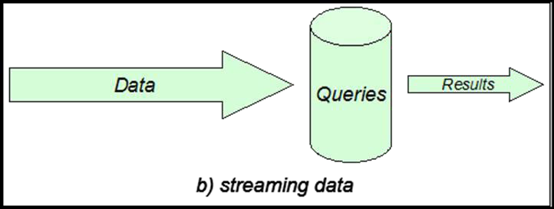

Figure 1.8: Streaming Data

The Big data analytics work on the unstructured data, where no specific pattern of the data is defined. The data is not organized in rows and columns. The live flow of data is captured and the analysis is done on it. xv.Efficiency increases when the data to be analyzed is large.

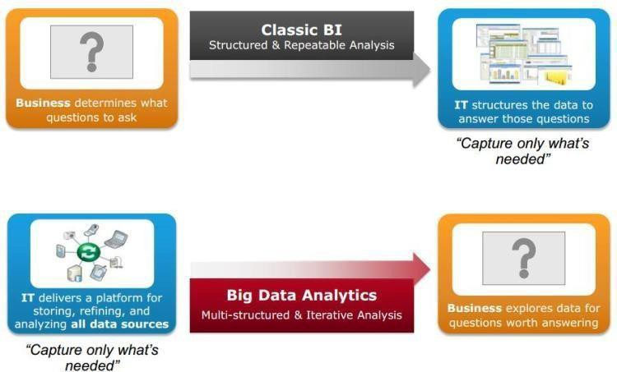

1.9 Big Data Architecture

# UNIT II

**INTRODUCTION TO HADOOP**

## Hadoop

* + 1. Hadoop is an open source framework that supports the processing of large data sets in a distributed computing environment.
    2. Hadoop consists of MapReduce, the Hadoop distributed file system (HDFS) and a number of related projects such as Apache Hive, HBase and Zookeeper. MapReduce and Hadoop distributed file system (HDFS) are the main component of Hadoop.
    3. Apache Hadoop is an open-source, free and Java based software framework offers a powerful distributed platform to store and manage Big Data.
    4. It is licensed under an Apache V2 license.
    5. It runs applications on large clusters of commodity hardware and it processes thousands of terabytes of data on thousands of the nodes. Hadoop is inspired from Google’s MapReduce and Google File System (GFS) papers.
    6. The major advantage of Hadoop framework is that it provides reliability and high availability.

## Use of Hadoop

There are many advantages of using Hadoop:

* + 1. Robust and Scalable – We can add new nodes as needed as well modify them.
    2. Affordable and Cost Effective – We do not need any special hardware for running Hadoop. We can just use commodity server.
    3. Adaptive and Flexible – Hadoop is built keeping in mind that it will handle structured and unstructured data.
    4. Highly Available and Fault Tolerant – When a node fails, the Hadoop framework automatically fails over to another node.

## Core Hadoop Components

There are two major components of the Hadoop framework and both of them does two of the important task for it.

* + 1. Hadoop MapReduce is the method to split a larger data problem into smaller chunk and distribute it to many different commodity servers. Each server have their own set of resources and they have processed them locally. Once the commodity server has processed the data they send it back collectively to main server. This is effectively a process where we process large data effectively and efficiently
    2. Hadoop Distributed File System (HDFS) is a virtual file system. There is a big difference between any other file system and Hadoop. When we move a file on HDFS, it is automatically split into many small pieces. These small chunks of the file are replicated and stored on other servers (usually 3) for the fault tolerance or high availability.
    3. Namenode: Namenode is the heart of the Hadoop system. The NameNode manages the file system namespace. It stores the metadata information of the data blocks. This metadata is

stored permanently on to local disk in the form of namespace image and edit log file. The NameNode also knows the location of the data blocks on the data node. However the NameNode does not store this information persistently. The NameNode creates the block to DataNode mapping when it is restarted. If the NameNode crashes, then the entire Hadoop system goes down. Read more about Namenode

* + 1. Secondary Namenode: The responsibility of secondary name node is to periodically copy and merge the namespace image and edit log. In case if the name node crashes, then the namespace image stored in secondary NameNode can be used to restart the NameNode.
    2. DataNode: It stores the blocks of data and retrieves them. The DataNodes also reports the blocks information to the NameNode periodically.
    3. Job Tracker: Job Tracker responsibility is to schedule the client’s jobs. Job tracker creates map and reduce tasks and schedules them to run on the DataNodes (task trackers). Job Tracker also checks for any failed tasks and reschedules the failed tasks on another DataNode. Job tracker can be run on the NameNode or a separate node.
    4. Task Tracker: Task tracker runs on the DataNodes. Task trackers responsibility is to run the map or reduce tasks assigned by the NameNode and to report the status of the tasks to the NameNode.

Besides above two core components Hadoop project also contains following modules as well.

1. Hadoop Common: Common utilities for the other Hadoop modules
2. Hadoop Yarn: A framework for job scheduling and cluster resource management

# RDBMS

Why can’t we use databases with lots of disks to do large-scale batch analysis? Why is MapReduce needed?

The answer to these questions comes from another trend in disk drives: seek time is improving more slowly than transfer rate. Seeking is the process of moving the disk’s head to a particular place on the disk to read or write data. It characterizes the latency of a disk operation, whereas the transfer rate corresponds to a disk’s bandwidth.

If the data access pattern is dominated by seeks, it will take longer to read or write large portions of the dataset than streaming through it, which operates at the transfer rate. On the other hand, for updating a small proportion of records in a database, a tradi- tional B-Tree (the data structure used in relational databases, which is limited by the rate it can perform seeks) works well. For updating the majority of a database, a B-Tree is less efficient than MapReduce, which uses Sort/Merge to rebuild the database.

In many ways, MapReduce can be seen as a complement to an RDBMS. (The differences between the two systems. MapReduce is a good fit for problems that need to analyze the whole dataset, in a batch fashion, particularly for ad hoc analysis. An RDBMS is good for point queries or updates, where the dataset has been indexed to deliver low-latency retrieval and update times of a relatively small amount of data. MapReduce suits applications where the data is written once,

and read many times, whereas a relational database is good for datasets that are continually updated.

Another difference between MapReduce and an RDBMS is the amount of structure in the datasets that they operate on. Structured data is data that is organized into entities that have a defined format, such as XML documents or database tables that conform to a particular predefined schema. This is the realm of the RDBMS. Semi-structured data, on the other hand, is looser, and though there may be a schema, it is often ignored, so it may be used only as a guide to the structure of the data: for example, a spreadsheet, in which the structure is the grid of cells, although the cells themselves may hold any form of data. Unstructured data does not have any particular internal structure: for example, plain text or image data. MapReduce works well on unstructured or semi- structured data, since it is designed to interpret the data at processing time. In other words, the input keys and values for MapReduce are not an intrinsic property of the data, but they are chosen by the person analyzing the data.

Relational data is often normalized to retain its integrity and remove redundancy. Normalization poses problems for MapReduce, since it makes reading a record a non- local operation, and one of the central assumptions that MapReduce makes is that it is possible to perform (high-speed) streaming reads and writes.

A web server log is a good example of a set of records that is not normalized (for ex- ample, the client hostnames are specified in full each time, even though the same client may appear many times), and this is one reason that logfiles of all kinds are particularly well-suited to analysis with MapReduce.

MapReduce is a linearly scalable programming model. The programmer writes two functions— a map function and a reduce function—each of which defines a mapping from one set of key- value pairs to another. These functions are oblivious to the size of the data or the cluster that they are operating on, so they can be used unchanged for a small dataset and for a massive one. More important, if you double the size of the input data, a job will run twice as slow. But if you also double the size of the cluster, a job will run as fast as the original one. This is not generally true of SQL queries.

Over time, however, the differences between relational databases and MapReduce sys- tems are likely to blur—both as relational databases start incorporating some of the ideas from MapReduce (such as Aster Data’s and Greenplum’s databases) and, from the other direction, as higher-level query languages built on MapReduce (such as Pig and Hive) make MapReduce systems more approachable to traditional database programmers.

# A BRIEF HISTORY OF HADOOP

Hadoop was created by Doug Cutting, the creator of Apache Lucene, the widely used text search library. Hadoop has its origins in Apache Nutch, an open source web search engine, itself a part of the Lucene project.

Building a web search engine from scratch was an ambitious goal, for not only is the software required to crawl and index websites complex to write, but it is also a challenge to run without a dedicated operations team, since there are so many moving parts. It’s expensive, too: Mike Cafarella and Doug Cutting estimated a system supporting a 1-billion-page index would cost around half a million dollars in hardware, with a monthly running cost of $30,000.Nevertheless, they believed it was a worthy goal, as it would open up and ultimately democratize search engine algorithms.

Nutch was started in 2002, and a working crawler and search system quickly emerged. However, they realized that their architecture wouldn’t scale to the billions of pages on the Web. Help was at hand with the publication of a paper in 2003 that described the architecture of Google’s distributed filesystem, called GFS, which was being used in production at Google.11 GFS, or something like it, would solve their storage needs for the very large files generated as a part of the web crawl and indexing process. In par- ticular, GFS would free up time being spent on administrative tasks such as managing storage nodes. In 2004, they set about writing an open source implementation, the Nutch Distributed Filesystem (NDFS).

In 2004, Google published the paper that introduced MapReduce to the world.12 Early in 2005, the Nutch developers had a working MapReduce implementation in Nutch, and by the middle of that year all the major Nutch algorithms had been ported to run using MapReduce and NDFS.

NDFS and the MapReduce implementation in Nutch were applicable beyond the realm of search, and in February 2006 they moved out of Nutch to form an independent subproject of Lucene called Hadoop. At around the same time, Doug Cutting joined Yahoo!, which provided a dedicated team and the resources to turn Hadoop into a system that ran at web scale (see sidebar). This was demonstrated in February 2008 when Yahoo! announced that its production search index was being generated by a 10,000-core Hadoop cluster.13

In January 2008, Hadoop was made its own top-level project at Apache, confirming its success and its diverse, active community. By this time, Hadoop was being used by many other companies besides Yahoo!, such as Last.fm, Facebook, and the New York Times.

In one well-publicized feat, the New York Times used Amazon’s EC2 compute cloud to crunch through four terabytes of scanned archives from the paper converting them to PDFs for the Web.14 The processing took less than 24 hours to run using 100 ma- chines, and the project probably wouldn’t have been embarked on without the com- bination of Amazon’s pay-by-the- hour model (which allowed the NYT to access a large number of machines for a short period) and Hadoop’s easy-to-use parallel programming model.

In April 2008, Hadoop broke a world record to become the fastest system to sort a terabyte of data. Running on a 910-node cluster, Hadoop sorted one terabyte in 209 seconds (just under 3½ minutes), beating the previous year’s winner of 297 seconds. In November of the same year, Google reported that its MapReduce implementation sorted one ter- abyte in 68 seconds.15 As the first edition of this book was going to press (May 2009), it was announced that a team at Yahoo! used Hadoop to sort one terabyte in 62 seconds.

# ANALYZING THE DATA WITH HADOOP

To take advantage of the parallel processing that Hadoop provides, we need to express our query as a MapReduce job. After some local, small-scale testing, we will be able to run it on a cluster of machines.

# MAP AND REDUCE

MapReduce works by breaking the processing into two phases: the map phase and the reduce phase. Each phase has key-value pairs as input and output, the types of which may be chosen by the programmer. The programmer also specifies two functions: the map function and the reduce function.

The input to our map phase is the raw NCDC data. We choose a text input format that gives us each line in the dataset as a text value. The key is the offset of the beginning of the line from the beginning of the file, but as we have no need for this, we ignore it.

Our map function is simple. We pull out the year and the air temperature, since these are the only fields we are interested in. In this case, the map function is just a data preparation phase, setting up the data in such a way that the reducer function can do its work on it: finding the maximum temperature for each year. The map function is also a good place to drop bad records: here we filter out temperatures that are missing, suspect, or erroneous.

To visualize the way the map works, consider the following sample lines of input data (some unused columns have been dropped to fit the page, indicated by ellipses):

0067011990999991950051507004...9999999N9+00001+99999999999...

0043011990999991950051512004...9999999N9+00221+99999999999...

0043011990999991950051518004...9999999N9-00111+99999999999...

0043012650999991949032412004...0500001N9+01111+99999999999...

0043012650999991949032418004...0500001N9+00781+99999999999...

These lines are presented to the map function as the key-value pairs:

(0, 0067011990999991950051507004...9999999N9+00001+99999999999...)

|  |  |
| --- | --- |
| (106, | 0043011990999991950051512004...9999999N9+00221+99999999999...) |
| (212, | 0043011990999991950051518004...9999999N9-00111+99999999999...) |
| (318, | 0043012650999991949032412004...0500001N9+01111+99999999999...) |
| (424, | 0043012650999991949032418004...0500001N9+00781+99999999999...) |

The keys are the line offsets within the file, which we ignore in our map function. The map function merely extracts the year and the air temperature (indicated in bold text), and emits them as its output (the temperature values have been interpreted as integers):

(1950, 0)

(1950, 22)

(1950, −11)

(1949, 111)

(1949, 78)

The output from the map function is processed by the MapReduce framework before being sent to the reduce function. This processing sorts and groups the key-value pairs by key. So, continuing the example, our reduce function sees the following input:

(1949, [111, 78])

(1950, [0, 22, −11])

Each year appears with a list of all itsair temperature readings. All the reduce function has to do now is iterate through the list and pick up the maximum reading:

(1949, 111)

(1950, 22)

This is the final output: the maximum global temperature recorded in each year.

The whole data flow is illustrated in 2.2. At the bottom of the diagram is a Unix pipeline, which mimics the whole MapReduce flow, and which we will see again later in the chapter when we look at Hadoop Streaming.

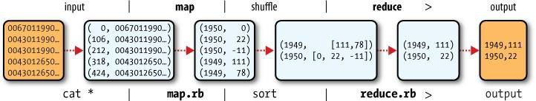

Figure 2-1. MapReduce logical data flow

# JAVA MAPREDUCE

Having run through how the MapReduce program works, the next step is to express it in code. We need three things: a map function, a reduce function, and some code to run the job. The map function is represented by the Mapper class, which declares an abstract map() method.

The Mapper class is a generic type, with four formal type parameters that specify the input key, input value, output key, and output value types of the map function. For the present example, the input key is a long integer offset, the input value is a line of text, the output key is a year, and the output value is an air temperature (an integer). Rather than use built-in Java types, Hadoop provides its own set of basic types that are opti- mized for network serialization. These are found in the org.apache.hadoop.io package. Here we use LongWritable, which corresponds to a Java Long, Text (like Java String), and IntWritable (like Java Integer).

The map() method is passed a key and a value. We convert the Text value containing the line of input into a Java String, then use its substring() method to extract the columns we are interested in.

The map() method also provides an instance of Context to write the output to. In this case, we write the year as a Text object (since we are just using it as a key), and the temperature is wrapped in an IntWritable. We write an output record only if the tem- perature is present and the quality code indicates the temperature reading is OK.

Again, four formal type parameters are used to specify the input and output types, this time for the reduce function. The input types of the reduce function must match the output types of the map function: Text and IntWritable. And in this case, the output types of the reduce function are Text and IntWritable, for a year and its maximum temperature, which we find by iterating through the temperatures and comparing each with a record of the highest found so far.

A Job object forms the specification of the job. It gives you control over how the job is run. When we run this job on a Hadoop cluster, we will package the code into a JAR file (which Hadoop will distribute around the cluster). Rather than explicitly specify the name of the JAR file, we can pass a class in the Job’s setJarByClass() method, which Hadoop will use to locate the relevant JAR file by looking for the JAR file containing this class.

Having constructed a Job object, we specify the input and output paths. An input path is specified by calling the static addInputPath() method on FileInputFormat, and it can be a single file, a directory (in which case, the input forms all the files in that directory), or a file pattern. As the name suggests, addInputPath() can be called more than once to use input from multiple paths.

The output path (of which there is only one) is specified by the static setOutput Path() method on FileOutputFormat. It specifies a directory where the output files from the reducer functions are written. The directory shouldn’t exist before running the job, as Hadoop will complain and not run the job. This precaution is to prevent data loss(it can be very annoying to accidentally overwrite the output of a long job with another).

Next, we specify the map and reduce types to use via the setMapperClass() and setReducerClass() methods.

The setOutputKeyClass() and setOutputValueClass() methods control the output types for the map and the reduce functions, which are often the same, as they are in our case. If they are different, then the map output types can be set using the methods setMapOutputKeyClass() and setMapOutputValueClass().

The input types are controlled via the input format, which we have not explicitly set since we are using the default TextInputFormat.

After setting the classes that define the map and reduce functions, we are ready to run the job. The waitForCompletion() method on Job submits the job and waits for it to finish. The method’s boolean argument is a verbose flag, so in this case the job writes information about its progress to the console.

The return value of the waitForCompletion() method is a boolean indicating success (true) or failure (false), which we translate into the program’s exit code of 0 or 1.

# A TEST RUN

After writing a MapReduce job, it’s normal to try it out on a small dataset to flush out any immediate problems with the code. First install Hadoop in standalone mode— there are instructions for how to do this in Appendix A. This is the mode in which Hadoop runs using the local filesystem with a local job runner. Then install and compile the examples using the instructions on the book’s website.

When the hadoop command is invoked with a classname as the first argument, it launches a JVM to run the class. It is more convenient to use hadoop than straight java since the former adds the Hadoop libraries (and their dependencies) to the class- path and picks up the Hadoop configuration, too. To add the application classes to the classpath, we’ve defined an environment variable called HADOOP_CLASSPATH, which the hadoop script picks up.

The last section of the output, titled “Counters,” shows the statistics that Hadoop generates for each job it runs. These are very useful for checking whether the amount of data processed is what you expected. For example, we can follow the number of records that went through the system: five map inputs produced five map outputs, then five reduce inputs in two groups produced two reduce outputs.

The output was written to the output directory, which contains one output file per reducer. The job had a single reducer, so we find a single file, named part-r-00000:

% cat output/part-r-00000 1949 111

1950 22

This result is the same as when we went through it by hand earlier. We interpret this as saying that the maximum temperature recorded in 1949 was 11.1°C, and in 1950 it was 2.2°C.

# THE OLD AND THE NEW JAVA MAPREDUCE APIS

The Java MapReduce API used in the previous section was first released in Hadoop

0.20.0. This new API, sometimes referred to as “Context Objects,” was designed to

make the API easier to evolve in the future. It is type-incompatible with the old, how- ever, so applications need to be rewritten to take advantage of it.

The new API is not complete in the 1.x (formerly 0.20) release series, so the old API is recommended for these releases, despite having been marked as deprecated in the early

0.20 releases. (Understandably, this recommendation caused a lot of confusion so the deprecation warning was removed from later releases in that series.)

Previous editions of this book were based on 0.20 releases, and used the old API throughout (although the new API was covered, the code invariably used the old API). In this edition the new API is used as the primary API, except where mentioned. How- ever, should you wish to use the old API, you can, since the code for all the examples in this book is available for the old API on the book’s website.1

There are several notable differences between the two APIs:

* The new API favors abstract classes over interfaces, since these are easier to evolve. For example, you can add a method (with a default implementation) to an abstract class without breaking old implementations of the class2. For example, the Mapper and Reducer interfaces in the old API are abstract classes in the new API.
* The new API is in the org.apache.hadoop.mapreduce package (and subpackages). The old API can still be found in org.apache.hadoop.mapred.
* The new API makes extensive use of context objects that allow the user code to communicate with the MapReduce system. The new Context, for example, essen- tially unifies the role of the JobConf, the OutputCollector, and the Reporter from the old API.
* In both APIs, key-value record pairs are pushed to the mapper and reducer, but in addition, the new API allows both mappers and reducers to control the execution flow by overriding the run() method. For example, records can be processed in batches, or the execution can be terminated before all the records have been pro- cessed. In the old API this is possible for mappers by writing a MapRunnable, but no equivalent exists for reducers.
* Configuration has been unified. The old API has a special JobConf object for job configuration, which is an extension of Hadoop’s vanilla Configuration object (used for configuring daemons. In the new API, this distinction is dropped, so job configuration is done through a Configuration.
* Job control is performed through the Job class in the new API, rather than the old

JobClient, which no longer exists in the new API.

* Output files are named slightly differently: in the old API both map and reduce outputs are named part-nnnnn, while in the new API map outputs are named part- m-nnnnn, and reduce outputs are named part-r-nnnnn (where nnnnn is an integer designating the part number, starting from zero).
* User-overridable methods in the new API are declared to throw java.lang.Inter ruptedException. What this means is that you can write your code to be reponsive to interupts so that the framework can gracefully cancel long-running operations if it needs to3.
* In the new API the reduce() method passes values as a java.lang.Iterable, rather than a java.lang.Iterator (as the old API does). This change makes it easier to iterate over the values using Java’s for-each loop construct: for (VALUEIN value : values) { ... }

## Hadoop Ecosystem

Although Hadoop is best known for MapReduce and its distributed filesystem (HDFS, renamed from NDFS), the term is also used for a family of related projects that fall under the umbrella of infrastructure for distributed computing and large-scale data processing.

All of the core projects covered in this book are hosted by the [Apache Software Foundation,](http://hadoop.apache.org/) which provides support for a community of open source software projects, including the original HTTP Server from which it gets its name. As the Hadoop eco- system grows, more projects are appearing, not necessarily hosted at Apache, which provide complementary services to Hadoop, or build on the core to add higher-level abstractions.

The Hadoop projects that are covered in this book are described briefly here:

*Common*

A set of components and interfaces for distributed filesystems and general I/O (serialization, Java RPC, persistent data structures).

*Avro*

A serialization system for efficient, cross-language RPC, and persistent data storage.

*MapReduce*

A distributed data processing model and execution environment that runs on large clusters of commodity machines.

*HDFS*

A distributed filesystem that runs on large clusters of commodity machines.

*Pig*

A data flow language and execution environment for exploring very large datasets. Pig runs on HDFS and MapReduce clusters.

*Hive*

A distributed data warehouse. Hive manages data stored in HDFS and provides a query language based on SQL (and which is translated by the runtime engine to MapReduce jobs) for querying the data.

*HBase*

A distributed, column-oriented database. HBase uses HDFS for its underlying storage, and supports both batch-style computations using MapReduce and point queries (random reads).

*ZooKeeper*

A distributed, highly available coordination service. ZooKeeper provides primitives such as distributed locks that can be used for building distributed applications.

*Sqoop*

A tool for efficiently moving data between relational databases and HDFS.

# PHYSICAL ARCHITECTURE

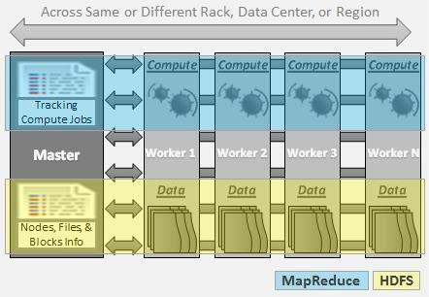

Figure 2.2: Physical Architecture

## Hadoop Cluster - Architecture, Core Components and Work-flow

* + 1. The architecture of Hadoop Cluster
    2. Core Components of Hadoop Cluster
    3. Work-flow of How File is Stored in Hadoop

1. Hadoop Cluster
   1. Hadoop cluster is a special type of computational cluster designed for storing and analyzing vast amount of unstructured data in a distributed computing environment

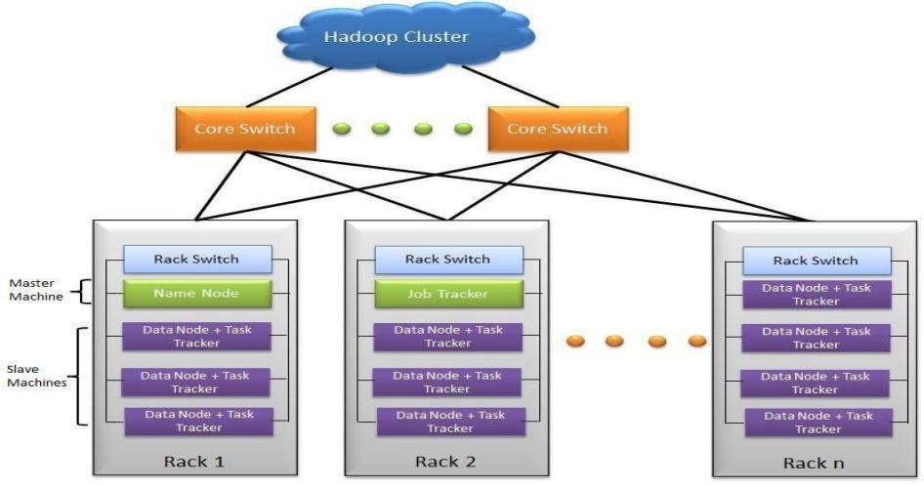

Figure 2.3: Hadoop Cluster

* 1. These clusters run on low cost commodity computers.
  2. Hadoop clusters are often referred to as "shared nothing" systems because the only thing that is shared between nodes is the network that connects them.

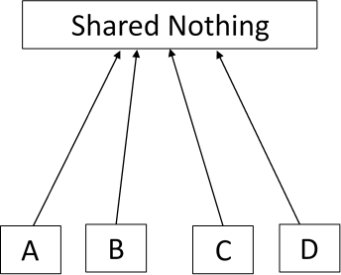

Figure 2.4: Shared Nothing

* 1. Large Hadoop Clusters are arranged in several racks. Network traffic between different nodes in the same rack is much more desirable than network traffic across the racks.

A Real Time Example: Yahoo's Hadoop cluster. They have more than 10,000 machines running Hadoop and nearly 1 petabyte of user data.

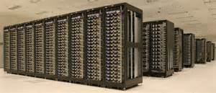

Figure 2.4: Yahoo Hadoop Cluster

* 1. A small Hadoop cluster includes a single master node and multiple worker or slave node. As discussed earlier, the entire cluster contains two layers.
  2. One of the layer of MapReduce Layer and another is of HDFS Layer.
  3. Each of these layer have its own relevant component.
  4. The master node consists of a JobTracker, TaskTracker, NameNode and DataNode.
  5. A slave or worker node consists of a DataNode and TaskTracker.

It is also possible that slave node or worker node is only data or compute node. The matter of the fact that is the key feature of the Hadoop.

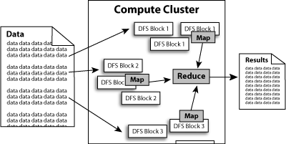

Figure 2.4: NameNode Cluster

1. HADOOP CLUSTER ARCHITECTURE:

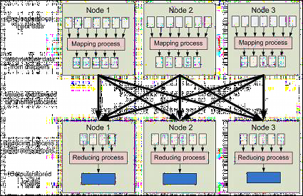

Figure 2.5: Hadoop Cluster Architecture Hadoop Cluster would consists of

* 110 different racks
* Each rack would have around 40 slave machine
* At the top of each rack there is a rack switch
* Each slave machine(rack server in a rack) has cables coming out it from both the ends
* Cables are connected to rack switch at the top which means that top rack switch will have around 80 ports
* There are global 8 core switches
* The rack switch has uplinks connected to core switches and henceconnecting all other racks with uniform bandwidth, forming the Cluster
* In the cluster, you have few machines to act as Name node and as JobTracker. They are referred as Masters. These masters have different configuration favoring more DRAM and CPU and less local storage.

Hadoop cluster has 3 components:

1. Client
2. Master
3. Slave

The role of each components are shown in the below image.

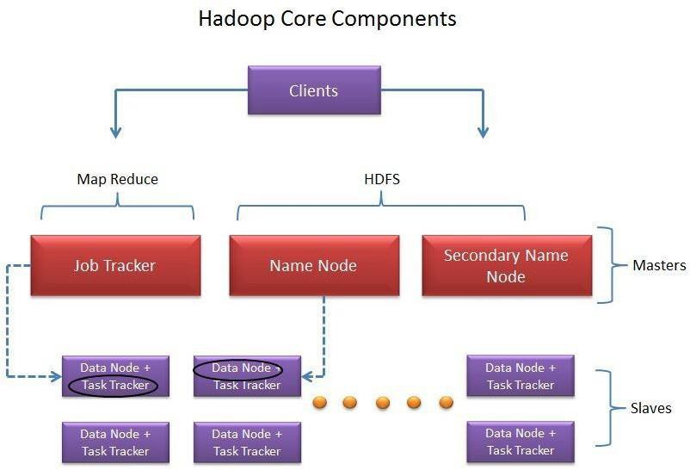

Figure 2.6: Hadoop Core Component

1. Client:
   1. It is neither master nor slave, rather play a role of loading the data into cluster, submit MapReduce jobs describing how the data should be processed and then retrieve the data to see the response after job completion.

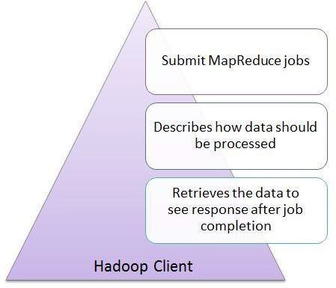

Figure 2.6: Hadoop Client

1. Masters:

The Masters consists of 3 components NameNode, Secondary Node name and JobTracker.

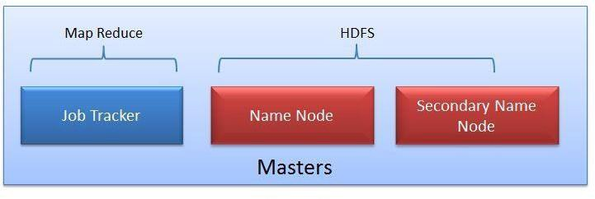

Figure 2.7: MapReduce - HDFS

* 1. NameNode:
* NameNode does NOT store the files but only the file's metadata. In later section we will see it is actually the DataNode which stores the files.

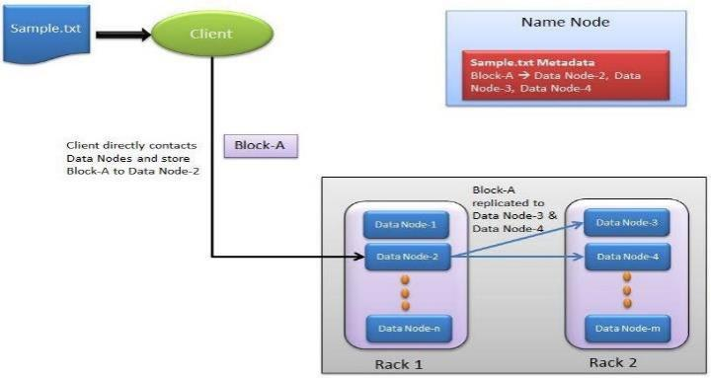

Figure 2.8: NameNode

* + NameNode oversees the health of DataNode and coordinates access to the data stored in DataNode.
  + Name node keeps track of all the file system related information such as to
    - Which section of file is saved in which part of the cluster
    - Last access time for the files
    - User permissions like which user have access to the file
  1. JobTracker:

JobTracker coordinates the parallel processing of data using MapReduce.

To know more about JobTracker, please read the article All You Want to Know about MapReduce (The Heart of Hadoop)

* 1. Secondary Name Node:

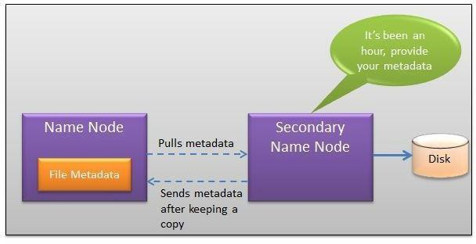

Figure 2.9: Secondary NameNode

* The job of Secondary Node is to contact NameNode in a periodic manner after certain time interval (by default 1 hour).
* NameNode which keeps all filesystem metadata in RAM has no capability to process that metadata on to disk.
* If NameNode crashes, you lose everything in RAM itself and you don't have any backup of filesystem.
* What secondary node does is it contacts NameNode in an hour and pulls copy of metadata information out of NameNode.
* It shuffle and merge this information into clean file folder and sent to back again to NameNode, while keeping a copy for itself.
* Hence Secondary Node is not the backup rather it does job of housekeeping.
* In case of NameNode failure, saved metadata can rebuild it easily.

## Slaves:

* 1. Slave nodes are the majority of machines in Hadoop Cluster and are responsible to
* Store the data
* Process the computation

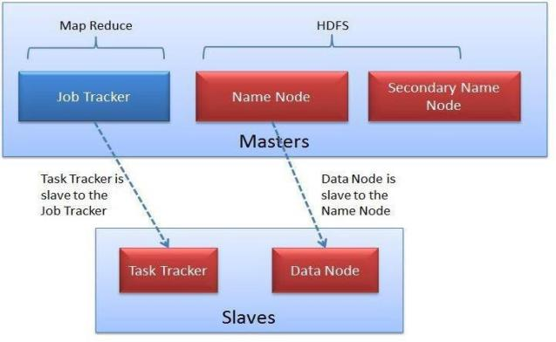

Figure 2.10: Slaves

* 1. Each slave runs both a DataNode and Task Tracker daemon which communicates to their masters.
  2. The Task Tracker daemon is a slave to the Job Tracker and the DataNode daemon a slave to the NameNode

1. **Hadoop- Typical Workflow in HDFS:**

Take the example of input file as Sample.txt.

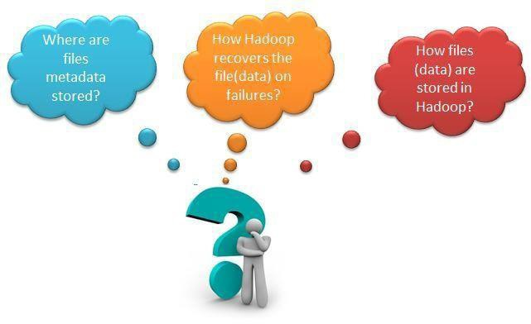

Figure 2.11: HDFS Workflow

* 1. How TestingHadoop.txt gets loaded into the Hadoop Cluster?

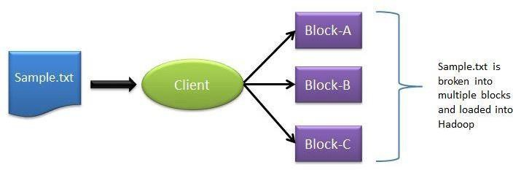

Figure 2.12: Loading file in Hadoop Cluster

* Client machine does this step and loads the Sample.txt into cluster.
* It breaks the sample.txt into smaller chunks which are known as "Blocks" in Hadoop context.
* Client put these blocks on different machines (data nodes) throughout the cluster.
  1. Next, how does the Client knows that to which data nodes load the blocks?
* Now NameNode comes into picture.
* The NameNode used its Rack Awareness intelligence to decide on which DataNode to provide.
* For each of the data block (in this case Block-A, Block-B and Block-C), Client contacts NameNode and in response NameNode sends an ordered list of 3 DataNodes.
  1. How does the Client knows that to which data nodes load the blocks?
* For example in response to Block-A request, Node Name may send DataNode-2, DataNode-3 and DataNode-4.
* Block-B DataNodes list DataNode-1, DataNode-3, DataNode-4 and for Block C data node list DataNode-1, DataNode-2, DataNode-3. Hence
* Block A gets stored in DataNode-2, DataNode-3, DataNode-4
* Block B gets stored in DataNode-1, DataNode-3, DataNode-4
* Block C gets stored in DataNode-1, DataNode-2, DataNode-3
* Every block is replicated to more than 1 data nodes to ensure the data recovery on the time of machine failures. That's why NameNode send 3 DataNodes list for each individual block
  1. Who does the block replication?
* Client write the data block directly to one DataNode. DataNodes then replicate the block to other Data nodes.
* When one block gets written in all 3 DataNode then only cycle repeats for next block.
  1. Who does the block replication?
* In Hadoop Gen 1 there is only one NameNode wherein Gen2 there is active passive model in NameNode where one more node "Passive Node" comes in picture.
* The default setting for Hadoop is to have 3 copies of each block in the cluster. This setting can be configured with "dfs.replication" parameter of hdfs-site.xml file.
* Keep note that Client directly writes the block to the DataNode without any intervention of NameNode in this process.

## Hadoop limitations

1. Network File system is the oldest and the most commonly used distributed file system and was designed for the general class of applications, Hadoop only specific kind of applications can make use of it.
2. It is known that Hadoop has been created to address the limitations of the distributed file system, where it can store the large amount of data, offers failure protection and provides fast access, but it should be known that the benefits that come with Hadoop come at some cost.
3. Hadoop is designed for applications that require random reads; so if a file has four parts the file would like to read all the parts one-by-one going from 1 to 4 till the end. Random seek is where you want to go to a specific location in the file; this issomething that isn’t possible with Hadoop. Hence, Hadoop is designed for non- real-time batch processing of data.
4. Hadoop is designed for streaming reads caching of data isn’t provided. Caching of data is provided which means that when you want to read data another time, it can be read very fast from the cache. This caching isn’t possible because you get faster access to the data directly by doing the sequential read; hence caching isn’t available through Hadoop.
5. It will write the data and then it will read the data several times. It will not be updating the data that it has written; hence updating data written to closed files is not available. However, you have to know that in update 0.19 appending will be supported for those files that aren’t closed.

But for those files that have been closed, updating isn’t possible.

1. In case of Hadoop we aren’t talking about one computer; in this scenario we usually have a large number of computers and hardware failures are unavoidable; sometime one computer will fail and sometimes the entire rack can fail too. Hadoop gives excellent protection against hardware failure; however the performance will go down proportionate to the number of computers that are down. In the big picture, it doesn’t really matter and it is not generally noticeable since if you have 100 computers and in them if 3 fail then 97 are still working. So the proportionate loss of performance isn’t that noticeable. However, the way Hadoop works there is the loss in performance. Now this loss of performance through hardware failures is something that is managed through replication strategy.

# UNIT-III

**THE HADOOP DISTRIBUTEDFILESYSTEM**

When a dataset outgrows the storage capacity of a single physical machine, it becomes necessary to partition it across a number of separate machines. Filesystems that manage the storage across a network of machines are called distributed filesystems. Since they are network- based, all the complications of network programming kick in, thus making distributed filesystems more complex than regular disk filesystems. For example, one of the biggest challenges is making the filesystem tolerate node failure without suffering data loss.

Hadoop comes with a distributed filesystem called HDFS, which stands for Hadoop Distributed Filesystem. (You may sometimes see references to “DFS”—informally or in older documentation or configurations—which is the same thing.) HDFS is Hadoop’s flagship filesystem and is the focus of this chapter, but Hadoop actually has a general- purpose filesystem abstraction, so we’ll see along the way how Hadoop integrates with other storage systems (such as the local filesystem and Amazon S3).

# THE DESIGN OF HDFS

HDFS is a filesystem designed for storing very large files with streaming data access patterns, running on clusters of commodity hardware.1 Let’s examine this statement in more detail:

# VERY LARGE FILES

“Very large” in this context means files that are hundreds of megabytes, gigabytes, or terabytes in size. There are Hadoop clusters running today that store petabytes of data.

# STREAMING DATA ACCESS

HDFS is built around the idea that the most efficient data processing pattern is a write-once, read- many-times pattern. A dataset is typically generated or copied from source, then various analyses are performed on that dataset over time. Each analysis will involve a large proportion, if not all, of the dataset, so the time to read the whole dataset is more important than the latency in reading the first record.

# COMMODITY HARDWARE

Hadoop doesn’t require expensive, highly reliable hardware to run on. It’s designed to run on clusters of commodity hardware (commonly available hardware available from multiple vendors3) for which the chance of node failure across the cluster is high, at least for large clusters. HDFS is designed to carry on working without a noticeable interruption to the user in the face of such failure.

It is also worth examining the applications for which using HDFS does not work so well. While this may change in the future, these are areas where HDFS is not a good fit today:

# LOW-LATENCY DATA ACCESS

Applications that require low-latency access to data, in the tens of milliseconds range, will not work well with HDFS. Remember, HDFS is optimized for delivering a high throughput of data, and this may be at the expense of latency. HBase is currently a better choice for low-latency access.

Since the namenode holds filesystem metadata in memory, the limit to the number of files in a filesystem is governed by the amount of memory on the namenode. As a rule of thumb, each file, directory, and block takes about 150 bytes. So, for example, if you had one million files, each taking one block, you would need at least 300 MB of memory. While storing millions of files is feasible, billions is be- yond the capability of current hardware.

# MULTIPLE WRITERS, ARBITRARY FILE MODIFICATIONS

Files in HDFS may be written to by a single writer. Writes are always made at the end of the file. There is no support for multiple writers, or for modifications at arbitrary offsets in the file. (These might be supported in the future, but they are likely to be relatively inefficient.)

# HDFS CONCEPTS BLOCKS

A disk has a block size, which is the minimum amount of data that it can read or write. Filesystems for a single disk build on this by dealing with data in blocks, which are an integral multiple of the disk block size. Filesystem blocks are typically a few kilobytes in size, while disk blocks are normally 512 bytes. This is generally transparent to the filesystem user who is simply reading or writing a file—of whatever length. However, there are tools to perform filesystem maintenance, such as df and fsck, that operate on the filesystem block level.

HDFS, too, has the concept of a block, but it is a much larger unit—64 MB by default. Like in a filesystem for a single disk, files in HDFS are broken into block-sized chunks, which are stored as independent units. Unlike a filesystem for a single disk, a file in HDFS that is smaller than a single block does not occupy a full block’s worth of underlying storage. When unqualified, the term “block” in this book refers to a block in HDFS.

Having ablockabstractionforadistributedfilesystembringsseveralbenefits. Thefirst benefit is the most obvious: a file can be larger than any single disk in the network. There’s nothing that requires the blocks from a file to be stored on the same disk, so they can take advantage of any of the disks in the cluster. In fact, it would be possible, if unusual, to store a single file on an HDFS cluster whose blocks filled all the disks in the cluster.

Second, making the unit of abstraction a block rather than a file simplifies the storage subsystem. Simplicity is something to strive for all in all systems, but is especially important for a distributed system in which the failure modes are so varied. The storage subsystem deals with blocks, simplifying storage management (since blocks are a fixed size, it is easy to calculate how many can be stored on a given disk) and eliminating metadata concerns (blocks are just a chunk of data to be stored—file metadata such as permissions information does not need to be stored with the blocks, so another system can handle metadata separately).

Furthermore, blocks fit well with replication for providing fault tolerance and availability. To insure against corrupted blocks and disk and machine failure, each block is replicated to a small number of physically separate machines (typically three). If a block becomes unavailable, a copy can be read from another location in a way that is trans- parent to the client. A block that is no longer available due to corruption or machine failure can be replicated from its alternative locations to other live machines to bring the replication factor back to the normal level. Similarly, some applications may choose to set a high replication factor for the blocks in a popular file to spread the read load on the cluster.

Like its disk filesystem cousin, HDFS’s fsck command understands blocks. For example, running:

% hadoop fsck / -files -blocks will list the blocks that make up each file in the filesystem.

# NAMENODES AND DATANODES

An HDFS cluster has two types of node operating in a master-worker pattern: a name- node (the master) and a number of datanodes (workers). The namenode manages the filesystem namespace. It maintains the filesystem tree and the metadata for all the files and directories in the tree. This information is stored persistently on the local disk in the form of two files: the namespace image and the edit log. The namenode also knows the datanodes on which all the blocks for a given file are located, however, it does not store block locations persistently, since this information is reconstructed from datanodes when the system starts.

A client accesses the filesystem on behalf of the user by communicating with the name- node and datanodes. The client presents a POSIX-like filesystem interface, so the user code does not need to know about the namenode and datanode to function.

Datanodes are the workhorses of the filesystem. They store and retrieve blocks when they are told to (by clients or the namenode), and they report back to the namenode periodically with lists of blocks that they are storing.

Without the namenode, the filesystem cannot be used. In fact, if the machine running the namenode were obliterated, all the files on the filesystem would be lost since there would be no way of knowing how to reconstruct the files from the blocks on the datanodes. For this reason, it is important to make the namenode resilient to failure, and Hadoop provides two mechanisms for this.

The first way is to back up the files that make up the persistent state of the filesystem metadata. Hadoop can be configured so that the namenode writes its persistent state to multiple filesystems. These writes are synchronous and atomic. The usual configu- ration choice is to write to local disk as well as a remote NFS mount.

It is also possible to run a secondary namenode, which despite its name does not act as a namenode. Its main role is to periodically merge the namespace image with the edit log to prevent the edit log from becoming too large. The secondary namenode usually runs on a separate physical machine, since it requires plenty of CPU and as much memory as the namenode to perform the merge. It keeps a copy of the merged name- space image, which can be used in the event of the namenode failing. However, the state of the secondary namenode lags that of the primary, so in the event of total failure of the primary, data loss is almost certain. The usual course of action in this case is to copy the namenode’s metadata files that are on NFS to the secondary and run it as the new primary.

# HDFS FEDERATION

The namenode keeps a reference to every file and block in the filesystem in memory, which means that on very large clusters with many files, memory becomes the limiting factor for scaling. HDFS Federation, introduced in the 0.23 release series, allows a cluster to scale by adding namenodes, each of which manages a portion of the filesystem namespace. For example, one namenode might manage all the files rooted under /user, say, and a second namenode might handle files under /share.

Under federation, each namenode manages a namespace volume, which is made up of the metadata for the namespace, and a block pool containing all the blocks for the files in the namespace. Namespace volumes are independent of each other, which means namenodes do not communicate with one another, and furthermore the failure of one namenode does not affect the availability of the namespaces managed by other namen- odes. Block pool storage is not partitioned, however, so datanodes register with each namenode in the cluster and store blocks from multiple block pools.

To access a federated HDFS cluster, clients use client-side mount tables to map file paths to namenodes. This is managed in configuration using the ViewFileSystem, and viewfs:// URIs.

# HDFS HIGH-AVAILABILITY

The combination of replicating namenode metadata on multiple filesystems, and using the secondary namenode to create checkpoints protects against data loss, but does not provide high- availability of the filesystem. The namenode is still a single point of fail- ure (SPOF), since if it did fail, all clients—including MapReduce jobs—would be un- able to read, write, or list files, because the namenode is the sole repository of the metadata and the file-to-block mapping. In such an event the whole Hadoop system would effectively be out of service until a new namenode could be brought online.

To recover from a failed namenode in this situation, an administrator starts a new primary namenode with one of the filesystem metadata replicas, and configures da- tanodes and clients to use this new namenode. The new namenode is not able to serve requests until it has i) loaded its namespace image into memory, ii) replayed its edit log, and iii) received enough block reports from the datanodes to leave safe mode. On large clusters with many files and blocks, the time it takes for a namenode to start from cold can be 30 minutes or more.

The long recovery time is a problem for routine maintenance too. In fact, since unex- pected failure of the namenode is so rare, the case for planned downtime is actually more important in practice.

The 0.23 release series of Hadoop remedies this situation by adding support for HDFS high- availability (HA). In this implementation there is a pair of namenodes in an active- standby configuration. In the event of the failure of the active namenode, the standby takes over its duties to continue servicing client requests without a significant inter- ruption. A few architectural changes are needed to allow this to happen:

The namenodes must use highly-available shared storage to share the edit log. (In the initial implementation of HA this will require an NFS filer, but in future releases more options will be provided, such as a BookKeeper-based system built on Zoo- Keeper.) When a standby namenode comes up it reads up to the end of the shared edit log to synchronize its state with the active namenode, and then continues to read new entries as they are written by the active namenode.

Datanodes must send block reports to both namenodes since the block mappings are stored in a namenode’s memory, and not on disk.

Clients must be configured to handle namenode failover, which uses a mechanism that is transparent to users.

If the active namenode fails, then the standby can take over very quickly (in a few tens of seconds) since it has the latest state available in memory: both the latest edit log entries, and an up-to-date block mapping. The actual observed failover time will be longer in practice (around a minute or so), since the system needs to be conservative in deciding that the active namenode has failed.

In the unlikely event of the standby being down when the active fails, the administrator can still start the standby from cold. This is no worse than the non-HA case, and from an operational point of view it’s an improvement, since the process is a standard op- erational procedure built into Hadoop.

# FAILOVER AND FENCING

The transition from the active namenode to the standby is managed by a new entity in the system called the failover controller. Failover controllers are pluggable, but the first implementation uses ZooKeeper to ensure that only one namenode is active. Each namenode

runs a lightweight failover controller process whose job it is to monitor its namenode for failures (using a simple heartbeating mechanism) and trigger a failover should a namenode fail.

Failover may also be initiated manually by an adminstrator, in the case of routine maintenance, for example. This is known as a graceful failover, since the failover con- troller arranges an orderly transition for both namenodes to switch roles.

In the case of an ungraceful failover, however, it is impossible to be sure that the failed namenode has stopped running. For example, a slow network or a network partition can trigger a failover transition, even though the previously active namenode is still running, and thinks it is still the active namenode. The HA implementation goes to great lengths to ensure that the previously active namenode is prevented from doing any damage and causing corruption—a method known as fencing. The system employs a range of fencing mechanisms, including killing the namenode’s process, revoking its access to the shared storage directory (typically by using a vendor-specific NFS com- mand), and disabling its network port via a remote management command. As a last resort, the previously active namenode can be fenced with a technique rather graphi- cally known as STONITH, or “shoot the other node in the head”, which uses a specialized power distribution unit to forcibly power down the host machine.

Client failover is handled transparently by the client library. The simplest implementation uses client-side configuration to control failover. The HDFS URI uses a logical hostname which is mapped to a pair of namenode addresses (in the configuration file), and the client library tries each namenode address until the operation succeeds.

# BASIC FILESYSTEM OPERATIONS

The filesystem is ready to be used, and we can do all of the usual filesystem operations such as reading files, creating directories, moving files, deleting data, and listing direc- tories. You can type hadoop fs -help to get detailed help on every command.

Start by copying a file from the local filesystem to HDFS:

% hadoop fs -copyFromLocal input/docs/quangle.txt hdfs://localhost/user/tom/ quangle.txt

This command invokes Hadoop’s filesystem shell command fs, which supports a number of subcommands—in this case, we are running -copyFromLocal. The local file quangle.txtis copiedtothefile/user/tom/quangle.txtonthe HDFSinstancerunning on localhost. In fact, we could have omitted the scheme and host of the URI and picked up the default, hdfs://localhost, as specified in core-site.xml:

% hadoop fs -copyFromLocal input/docs/quangle.txt /user/tom/quangle.txt

We could also have used a relative path and copied the file to our home directory in HDFS, which in this case is /user/tom:

% hadoop fs -copyFromLocal input/docs/quangle.txt quangle.txt

Let’s copy the file back to the local filesystem and check whether it’s the same:

% hadoop fs -copyToLocal quangle.txt quangle.copy.txt

% md5 input/docs/quangle.txt quangle.copy.txt

MD5 (input/docs/quangle.txt) = a16f231da6b05e2ba7a339320e7dacd9 MD5 (quangle.copy.txt)

= a16f231da6b05e2ba7a339320e7dacd9

The MD5 digests are the same, showing that the file survived its trip to HDFS and is back intact.

Finally, let’s look at an HDFS file listing. We create a directory first just to see how it is displayed in the listing:

% hadoop fs -mkdir books

% hadoop fs -ls .

Found 2 items

drwxr-xr-x- tom supergroup 0 2009-04-02 22:41 /user/tom/books-rw-r--r--1 tom

supergroup 2009-04-02 22:29 /user/tom/quangle.txt

The information returned is very similar to the Unix command ls -l, with a few minor differences. The first column shows the file mode. The second column is the replication factor of the file (something a traditional Unix filesystem does not have). Remember we set the default replication factor in the site-wide configuration to be 1, which is why we see the same value here. The entry in this column is empty for directories since the concept of replication does not apply to them—directories are treated as metadata and stored by the namenode, not the datanodes. The third and fourth columns show the file owner and group. The fifth column is the size of the file in bytes, or zero for directories. The sixth and seventh columns are the last modified date and time. Finally, the eighth column is the absolute name of the file or directory

# HADOOP FILESYSTEMS

Hadoop has an abstract notion of filesystem, of which HDFS is just one implementation. The Java abstract class org.apache. hadoop .fs. File System represents a filesystem in Hadoop, and there are several concrete implementations

Hadoop provides many interfaces to its filesystems, and it generally uses the URI scheme to pick the correct filesystem instance to communicate with. For example, the filesystem shell that we met in the previous section operates with all Hadoop filesys- tems. To list the files in the root directory of the local filesystem, type:

% hadoop fs -ls file:///

Although it is possible (and sometimes very convenient) to run MapReduce programs that access any of these filesystems, when you are processing large volumes of data, you should choose a distributed filesystem that has the data locality optimization, notably HDFS.

# INTERFACES

Hadoop is written in Java, and all Hadoop filesystem interactions are mediated through the Java API. The filesystem shell, for example, is a Java application that uses the Java FileSystem class to provide filesystem operations. The other filesystem interfaces are discussed briefly in this section. These interfaces are most commonly used with HDFS, since the other filesystems in Hadoop typically have existing tools to access the under- lying filesystem (FTP clients for FTP, S3 tools for S3, etc.), but many of them will work with any Hadoop filesystem.

# HTTP

There are two ways of accessing HDFS over HTTP: directly, where the HDFS daemons serve HTTP requests to clients; and via a proxy (or proxies), which accesses HDFS on the client’s behalf using the usual Distributed File System API.

In the first case, directory listings are served by the namenode’s embedded web server (which runs on port 50070) formatted in XML or JSON, while file data is streamed from datanodes by their web servers (running on port 50075).

The original direct HTTP interface (HFTP and HSFTP) was read-only, while the new WebHDFS implementation supports all filesystem operations, including Kerberos authentication. Web HDFS must be enabled by setting dfs. web hdfs. enabled to true, for you to be able to use webhdfs URIs.

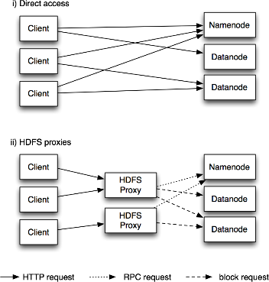

Figure 3-1. Accessing HDFS over HTTP directly, and via a bank of HDFS proxies

The second way of accessing HDFS over HTTP relies on one or more standalone proxy servers. (The proxies are stateless so they can run behind a standard load balancer.) All traffic to the cluster passes through the proxy. This allows for stricter firewall and bandwidth limiting policies to be put in place. It’s common to use a proxy for transfers between Hadoop clusters located in different data centers.

The original HDFS proxy (in src/contrib/hdfsproxy) was read-only, and could be ac- cessed by clients using the HSFTP FileSystem implementation (hsftp URIs). From re- lease 0.23, there is a new proxy called HttpFS that has read and write capabilities, and which exposes the same HTTP interface as WebHDFS, so clients can access either using webhdfs URIs.

The HTTP REST API that WebHDFS exposes is formally defined in a specification, so it is likely that over time clients in languages other than Java will be written that use it directly.

# C

Hadoop provides a C library called libhdfs that mirrors the Java FileSystem interface (it was written as a C library for accessing HDFS, but despite its name it can be used to access any Hadoop filesystem). It works using the Java Native Interface (JNI) to call a Java filesystem client.

The C API is very similar to the Java one, but it typically lags the Java one, so newer features may not be supported. You can find the generated documentation for the C API in the libhdfs/docs/api directory of the Hadoop distribution.

Hadoop comes with prebuilt libhdfs binaries for 32-bit Linux, but for other platforms, you will need to build them yourself using the instructions at [http://wiki.apache.org/](http://wiki.apache.org/hadoop/LibHDFS) [hadoop/LibHDFS.](http://wiki.apache.org/hadoop/LibHDFS)

# FUSE

Filesystem in Userspace (FUSE) allows filesystems that are implemented in user space to be integrated as a Unix filesystem. Hadoop’s Fuse-DFS contrib module allows any Hadoop filesystem (but typically HDFS) to be mounted as a standard filesystem. You can then use Unix utilities (such as ls and cat) to interact with the filesystem, as well as POSIX libraries to access the filesystem from any programming language.

Fuse-DFS is implemented in C using libhdfs as the interface to HDFS. Documentation for compiling and running Fuse-DFS is located in the src/contrib/fuse-dfs directory of the Hadoop distribution.

# THE JAVAINTERFACE

In this section, we dig into the Hadoop’s FileSystem class: the API for interacting with one of Hadoop’s filesystems.5 While we focus mainly on the HDFS implementation, DistributedFileSystem, in general you should strive to write your code against the FileSystem abstract class, to retain portability across filesystems. This is very useful when testing your program, for example, since you can rapidly run tests using data stored on the local filesystem.

# READING DATA FROM A HADOOP URL

One of the simplest ways to read a file from a Hadoop filesystem is by using a

java.net.URL object to open a stream to read the data from. The general idiom is:

InputStream in = null; try {

in = new URL("hdfs://host/path").openStream();

// process in

} finally { IOUtils.closeStream(in);

}

There’s a little bit more work required to make Java recognize Hadoop’s hdfs URL scheme. This is achieved by calling the setURLStreamHandlerFactory method on URL

* 1. From release 0.21.0, there is a new filesystem interface called FileContext with better handling of multiple filesystems (so a single FileContext can resolve multiple filesystem schemes, for example) and a cleaner, more consistent interface.
  2. with an instance of Fs Url Stream Handler Factory. This method can only be called once per JVM, so it is typically executed in a static block. This limitation means that if some other part of your program—perhaps a third-party component outside your control— sets a URL Stream Handler Factory, you won’t be able to use this approach for reading data from Hadoop. The next section discusses an alternative.

Program for displaying files from Hadoop filesystems on standard output, like the Unix cat command.

Example 3-1. Displaying files from a Hadoop filesystem on standard output using a URLStreamHandler

public class URLCat {

3.

static {

URL.setURLStreamHandlerFactory(new FsUrlStreamHandlerFactory());

}

4.

public static void main(String[] args) throws Exception { InputStream in = null; try {

in = new URL(args[0]).openStream(); IOUtils.copyBytes(in, System.out, 4096, false);

} finally { IOUtils.closeStream(in);

}

}

We make use of the handy IOUtils class that comes with Hadoop for closing the stream in the finally clause, and also for copying bytes between the input stream and the output stream (System.out in this case). The last two arguments to the copyBytes method are the buffer

size used for copying and whether to close the streams when the copy is complete. We close the input stream ourselves, and System.out doesn’t need to be closed.

# READING DATA USING THE FILESYSTEM API

As the previous section explained, sometimes it is impossible to set a URLStreamHand lerFactory for your application. In this case, you will need to use the FileSystem API to open an input stream for a file.

A file in a Hadoop filesystem is represented by a Hadoop Path object (and not a java.io.File object, since its semantics are too closely tied to the local filesystem). You can think of a Path as a Hadoop filesystem URI, such as hdfs://localhost/user/tom/ quangle.txt.

FileSystem is a general filesystem API, so the first step is to retrieve an instance for the filesystem we want to use—HDFS in this case. There are several static factory methods for getting a FileSystem instance:

public static FileSystem get(Configuration conf) throws IOException

public static FileSystem get(URI uri, Configuration conf) throws IOException

public static FileSystem get(URI uri, Configuration conf, String user) throws IOException

A Configuration object encapsulates a client or server’s configuration, which is set using configuration files read from the classpath, such as conf/core-site.xml. The first method returns the default filesystem (as specified in the file conf/core-site.xml, or the default local filesystem if not specified there). The second uses the given URI’s scheme and authority to determine the filesystem to use, falling back to the default filesystem if no scheme is specified in the given URI. The third retrieves the filesystem as the given user.

In some cases, you may want to retrieve a local filesystem instance, in which case you can use the convenience method, getLocal():

public static LocalFileSystem getLocal(Configuration conf) throws IOException

With a FileSystem instance in hand, we invoke an open() method to get the input stream for a file:

public FSDataInputStream open(Path f) throws IOException

public abstract FSDataInputStream open(Path f, int bufferSize) throws IOException

The first method uses a default buffer size of 4 K.

Putting this together, we can rewrite Example 3-1 as shown in Example 3-2.

Example 3-2. Displaying files from a Hadoop filesystem on standard output by using the FileSystem directly

public class FileSystemCat {

public static void main(String[] args) throws Exception { String uri = args[0]; Configuration conf = new Configuration();

FileSystem fs = FileSystem.get(URI.create(uri), conf); InputStream in = null; try {

in = fs.open(new Path(uri)); IOUtils.copyBytes(in, System.out, 4096, false);

} finally { IOUtils.closeStream(in);

}

}

}

## FS Data Input Stream

The open() method on FileSystem actually returns a FSDataInputStream rather than a standard java.io class. This class is a specialization of java.io.DataInputStream with support for random access, so you can read from any part of the stream:

package org.apache.hadoop.fs;

public class FSDataInputStream extends DataInputStream implements Seekable, PositionedReadable {

// implementation elided

}

The Seekable interface permits seeking to a position in the file and a query method for the current offset from the start of the file (getPos()):

public interface Seekable {

void seek(long pos) throws IOException; long getPos() throws IOException;

}

Calling seek() with a position that is greater than the length of the file will result in an IOException. Unlike the skip() method of java.io.InputStream that positions the stream at

a point later than the current position, seek() can move to an arbitrary, ab- solute position in the file.

Example 3-3 is a simple extension of Example 3-2 that writes a file to standard out twice: after writing it once, it seeks to the start of the file and streams through it once again.

Example 3-3. Displaying files from a Hadoop filesystem on standard output twice, by using seek public class FileSystemDoubleCat {

public static void main(String[] args) throws Exception { String uri = args[0]; Configuration conf = new Configuration();

FileSystem fs = FileSystem.get(URI.create(uri), conf); FSDataInputStream in = null; try {

in = fs.open(new Path(uri)); IOUtils.copyBytes(in, System.out, 4096, false); in.seek(0); // go back to the start of the file IOUtils.copyBytes(in, System.out, 4096, false);

} finally { IOUtils.closeStream(in);

}

}

}

Here’s the result of running it on a small file:

FSDataInputStream also implements the PositionedReadable interface for reading parts of a file at a given offset:

public interface PositionedReadable {

public int read(long position, byte[] buffer, int offset, int length) throws IOException;

public void readFully(long position, byte[] buffer, int offset, int length) throws IOException;

public void readFully(long position, byte[] buffer) throws IOException;

}

The read() method reads up to length bytes from the given position in the file into the buffer at the given offset in the buffer. The return value is the number of bytes actually

read: callers should check this value as it may be less than length. The readFully() methodswillreadlength bytesintothebuffer(orbuffer.length bytesfor theversion

that just takes a byte array buffer), unless the end of the file is reached, in which case an EOFException is thrown.

All of these methods preserve the current offset in the file and are thread-safe, so they provide a convenient way to access another part of the file—metadata perhaps—while reading the main body of the file. In fact, they are just implemented using the Seekable interface using the following pattern:

long oldPos = getPos(); try { seek(position);

// read data

} finally { seek(oldPos);

}

Finally, bear in mind that calling seek() is a relatively expensive operation and should be used sparingly. You should structure your application access patterns to rely on streaming data, (by using MapReduce, for example) rather than performing a large number of seeks.

# WRITING DATA

The File System class has a number of methods for creating a file. The simplest is the method that takes a Path object for the file to be created and returns an output stream to write to:

public FS Data Output Stream create(Path f) throws IOException

There are overloaded versions of this method that allow you to specify whether to forcibly overwrite existing files, the replication factor of the file, the buffer size to use when writing the file, the block size for the file, and file permissions.

There’s also an overloaded method for passing a callback interface, Progressable, so your application can be notified of the progress of the data being written to the datanodes:

package org.apache.hadoop.util;

public interface Progressable { public void progress();

}

As an alternative to creating a new file, you can append to an existing file using the append() method (there are also some other overloaded versions):

public FSDataOutputStream append(Path f) throws IOException

The append operation allows a single writer to modify an already written file by opening it and writing data from the final offset in the file. With this API, applications that produce unbounded files, such as logfiles, can write to an existing file after a restart, for example. The append operation is optional and not implemented by all Hadoop filesystems. For example, HDFS supports append, but S3 filesystems don’t.

To copy a local file to a Hadoop filesystem. We illustrate pro- gress by printing a period every time the progress() method is called by Hadoop, which is after each 64 K packet of data is written to the datanode pipeline. (Note that this particular behavior is not specified by the API, so it is subject to change in later versions of Hadoop. The API merely allows you to infer that “something is happening.”)

Example 3-4. Copying a local file to a Hadoop filesystem public class FileCopyWithProgress {

public static void main(String[] args) throws Exception { String localSrc = args[0]; String dst = args[1];

InputStream in = new BufferedInputStream(new FileInputStream(localSrc)); Configuration conf = new Configuration();

FileSystem fs = FileSystem.get(URI.create(dst), conf); OutputStream out = fs.create(new Path(dst), new Progressable() {

public void progress() { System.out.print(".");

}

});

IOUtils.copyBytes(in, out, 4096, true);

}

}

Typical usage:

% hadoop FileCopyWithProgress input/docs/1400-8.txt hdfs://localhost/user/tom/ 1400-8.txt

Currently, none of the other Hadoop filesystems call progress() during writes. Progress is important in MapReduce applications, as you will see in later chapters.

## FS Data Output Stream

The create() method on FileSystem returns an FSDataOutputStream, which, like FSDataInputStream, has a method for querying the current position in the file: package org.apache.hadoop.fs;

public class FSDataOutputStream extends DataOutputStream implements Syncable { public long getPos() throws IOException {

// implementation elided

}

// implementation elided

}

However, unlike FS Data Input Stream, FS Data Output Stream does not permit seeking. This is because HDFS allows only sequential writes to an open file or appends to an already written file. In other words, there is no support for writing to anywhere other than the end of the file, so there is no value in being able to seek while writing.

# DATA FLOW

**ANATOMY OF A FILE READ**

To get an idea of how data flows between the client interacting with HDFS, the name- node and the datanodes, which shows the main sequence of events when reading a file.

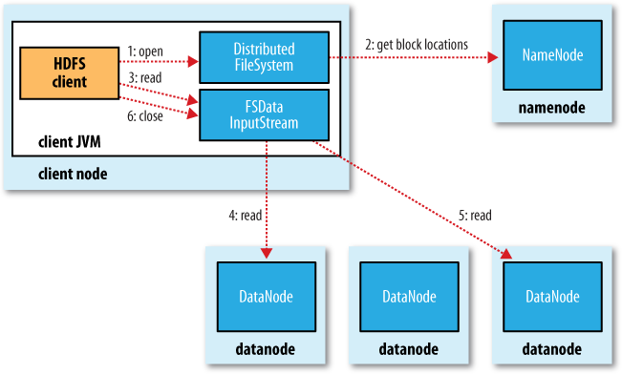

Figure 3-2. A client reading data from HDFS

The client opens the file it wishes to read by calling open() on the File System object, which for HDFS is an instance of Distributed File System Distributed File System calls the

namenode, using RPC, to determine the locations of the blocks for the first few blocks in the file (step 2). For each block, the namenode returns the addresses of the datanodes that have a copy of that block. Furthermore, the datanodes are sorted according to their proximity to the client (according to the top- ology of the cluster’s network; see “Network Topology and Hadoop” ). If the client is itself a datanode (in the case of a MapReduce task, for instance), then it will read from the local datanode, if it hosts a copy of the block.

The DistributedFileSystem returns an FSDataInputStream (an input stream that sup- ports file seeks) to the client for it to read data from. FSDataInputStream in turn wraps a DFSInputStream, which manages the datanode and namenode I/O.

The client then calls read() on the stream (step 3). DFSInputStream, which has stored the datanode addresses for the first few blocks in the file, then connects to the first (closest) datanode for the first block in the file. Data is streamed from the datanode back to the client, which calls read() repeatedly on the stream (step 4). When the end of the block is reached, DFSInputStream will close the connection to the datanode, then find the best datanode for the next block (step 5). This happens transparently to the client, which from its point of view is just reading a continuous stream.

Blocks are read in order with the DFSInputStream opening new connections to datanodes as the client reads through the stream. It will also call the namenode to retrieve the datanode locations for the next batch of blocks as needed. When the client has finished reading, it calls close() on the FSDataInputStream (step 6).

During reading, if the DFSInputStream encounters an error while communicating with a datanode, then it will try the next closest one for that block. It will also remember datanodes that have failed so that it doesn’t needlessly retry them for later blocks. The DFSInputStream also verifies checksums for the data transferred to it from the datanode. If a corrupted block is found, it is reported to the namenode before the DFSInput Stream attempts to read a replica of the block from another datanode.

One important aspect of this design is that the client contacts datanodes directly to retrieve data and is guided by the namenode to the best datanode for each block. This design allows HDFS to scale to a large number of concurrent clients, since the data traffic is spread across all the datanodes in the cluster. The namenode meanwhile merely has to service block location requests (which it stores in memory, making them very efficient) and does not, for example, serve data, which would quickly become a bot- tleneck as the number of clients grew.

# ANATOMY OF A FILE WRITE

Next we’ll look at how files are written to HDFS. Although quite detailed, it is instructive to understand the data flow since it clarifies HDFS’s coherency model.

The case we’re going to consider is the case of creating a new file, writing data to it, then closing the file.

The client creates the file by calling create() on Distributed Filesystem (step 1 in Distributed Filesystem makes an RPC call to the name node to create a new file in the filesystem’s namespace, with no blocks associated with it (step 2). The name- node performs various checks to make sure the file doesn’t already exist, and that the client has the right permissions to create the file. If these checks pass, the name node makes a record of the new file; otherwise, file creation fails and the client is thrown an IOException. The Distributed Filesystem returns an FS Data Output Stream for the client

to start writing data to. Just as in the read case, FSDataOutputStream wraps a DFSOutput Stream, which handles communication with the datanodes and namenode.

As the client writes data (step 3), DFS Output Stream splits it into packets, which it writes to an internal queue, called the data queue. The data queue is consumed by the Data Streamer, whose responsibility it is to ask the name node to allocate new blocks by picking a list of suitable datanodes to store the replicas. The list of datanodes forms a pipeline—we’ll assume the replication level is three, so there are three nodes in the pipeline. The Data Streamer streams the packets to the first datanode in the pipeline, which stores the packet and forwards it to the second datanode in the pipeline. Similarly, the second datanode stores the packet and forwards it to the third (and last) datanode in the pipeline (step 4).

DFS Output Stream also maintains an internal queue of packets that are waiting to be acknowledged by datanodes, called the ack queue. A packet is removed from the ack queue only when it has been acknowledged by all the datanodes in the pipeline (step 5).

If a datanode fails while data is being written to it, then the following actions are taken, which are transparent to the client writing the data. First the pipeline is closed, and any packets in the ack queue are added to the front of the data queue so that datanodes that are downstream from the failed node will not miss any packets. The current block on the good datanodes is given a new identity, which is communicated to the name- node, so that the partial block on the failed datanode will be deleted if the failed.

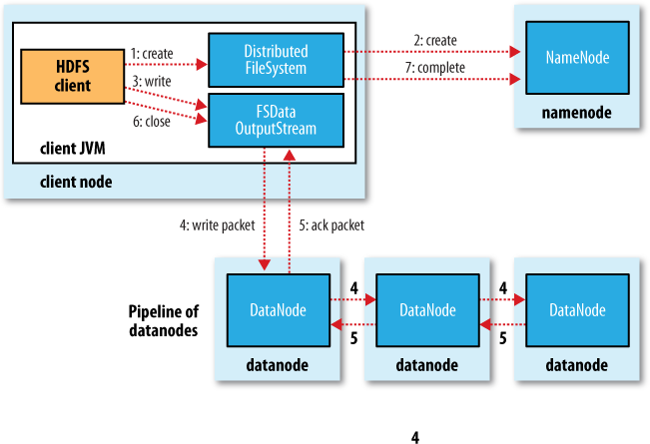

Figure 3-4. A client writing data to HDFS

datanode recovers later on. The failed datanode is removed from the pipeline and the remainder of the block’s data is written to the two good datanodes in the pipeline. The namenode notices that the block is under-replicated, and it arranges for a further replica to be created on another node. Subsequent blocks are then treated as normal.

It’s possible, but unlikely, that multiple datanodes fail while a block is being written. As long as dfs.replication .min replicas (default one) are written, the write will succeed, and the block will be asynchronously replicated across the cluster until its target rep- lication factor is reached (dfs.replication, which defaults to three).

When the client has finished writing data, it calls close() on the stream (step 6). This action flushes all the remaining packets to the datanode pipeline and waits for ac- knowledgments before contacting the namenode to signal that the file is complete (step 7). The namenode already knows which blocks the file is made up of (via Data Streamer asking for block allocations), so it only has to wait for blocks to be minimally replicated before returning successfully.

# LIMITATIONS

There are a few limitations to be aware of with HAR files. Creating an archive creates a copy of the original files, so you need as much disk space as the files you are archiving to create the archive (although you can delete the originals once you have created the archive). There is currently no support for archive compression, although the files that go into the archive can be compressed (HAR files are like tar files in this respect).

Archives are immutable once they have been created. To add or remove files, you must re-create the archive. In practice, this is not a problem for files that don’t change after being written, since they can be archived in batches on a regular basis, such as daily or weekly.

As noted earlier, HAR files can be used as input to MapReduce. However, there is no archive- aware InputFormat that can pack multiple files into a single MapReduce split, so processing

lots of small files, even in a HAR file, can still be inefficient. “Small files and Combine File Input Format” discusses another approach to this problem.

Finally, if you are hitting namenode memory limits even after taking steps to minimize the number of small files in the system, then consider using HDFS Federation to scale the namespace

# UNIT IV

**UNDERSTANDING MAP REDUCE FUNDAMENTALS**

## MapReduce

1. Traditional Enterprise Systems normally have a centralized server to store and process data.
2. The following illustration depicts a schematic view of a traditional enterprise system. Traditional model is certainly not suitable to process huge volumes of scalable data and cannot be accommodated by standard database servers.
3. Moreover, the centralized system creates too much of a bottleneck while processing multiple files simultaneously.

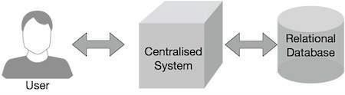

Figure 4.1: MapReduce

1. Google solved this bottleneck issue using an algorithm called MapReduce. MapReduce divides a task into small parts and assigns them to many computers.
2. Later, the results are collected at one place and integrated to form the result dataset.

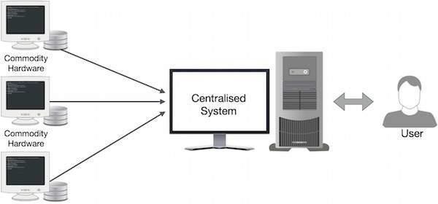

Figure 4.2: Physical structure

1. A MapReduce computation executes as follows:
   * Some number of Map tasks each are given one or more chunks from a distributed file system. These Map tasks turn the chunk into a sequence of key-value pairs. The way key-value pairs are produced from the input data is determined by the code written by the user for the Map function.
   * The key-value pairs from each Map task are collected by a master controller and sorted by key. The keys are divided among all the Reduce tasks, so all key-value pairs with the same key wind up at the same Reduce task.
   * The Reduce tasks work on one key at a time, and combine all the values associated with that key in some way. The manner of combination of values is determined by the code written by the user for the Reduce function.

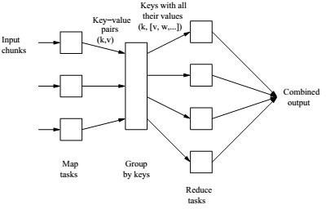

Figure 4.3: Schematic MapReduce Computation

## The Map Task

* 1. We view input files for a Map task as consisting of elements, which can be any type: a tuple or a document, for example.
  2. A chunk is a collection of elements, and no element is stored across two chunks.
  3. Technically, all inputs to Map tasks and outputs from Reduce tasks are of the key-value-pair form, but normally the keys of input elements are not relevant and we shall tend to ignore them.
  4. Insisting on this form for inputs and outputs is motivated by the desire to allow composition of several MapReduce processes.
  5. The Map function takes an input element as its argument and produces zero or more key-value pairs.
  6. The types of keys and values are each arbitrary. vii. Further, keys are not “keys” in the usual sense; they do not have to be unique.
  7. Rather a Map task can produce several key-value pairs with the same key, even from the same element.

**Example 1**: A MapReduce computation with what has become the standard example application: counting the number of occurrences for each word in a collection of documents. In this example, the input file is a repository of documents, and each document is an element. The Map function for this example uses keys that are of type String (the words) and values that are integers. The Map task reads a document and breaks it into its sequence of words w1, w2, . . . , wn. It then emits a sequence of key- value pairs where the value is always 1. That is, the output of the Map task for this document is the sequence of key-value pairs:

(w1, 1), (w2, 1), . . . , (wn, 1)

A single Map task will typically process many documents – all the documents in one or more chunks. Thus, its output will be more than the sequence for the one document suggested above. If a word *w* appears *m* times among all the documents assigned to that process, then there will be m key-value pairs (w, 1) among its output. An option, is to combine these m pairs into a single pair (w, m), but

we can only do that because, the Reduce tasks apply an associative and commutative operation, addition, to the values.

## Grouping by Key

* 1. As the Map tasks have all completed successfully, the key-value pairs are grouped by key, and the values associated with each key are formed into a list of values.
  2. The grouping is performed by the system, regardless of what the Map and Reduce tasks do.
  3. The master controller process knows how many Reduce tasks there will be, say r such tasks.
  4. The user typically tells the MapReduce system what r should be.
  5. Then the master controller picks a hash function that applies to keys and produces a bucket number from 0 to r − 1.
  6. Each key that is output by a Map task is hashed and its key-value pair is put in one of r local files. Each file is destined for one of the Reduce tasks.1.
  7. To perform the grouping by key and distribution to the Reduce tasks, the master controller merges the files from each Map task that are destined for a particular Reduce task and feeds the merged file to that process as a sequence of key-list-of-value pairs.
  8. That is, for each key k, the input to the Reduce task that handles key k is a pair of the form (k, [v1, v2, . . . , vn]), where (k, v1), (k, v2), . . . , (k, vn) are all the key-value pairs with key k coming from all the Map tasks.

## The Reduce Task

* 1. The Reduce function’s argument is a pair consisting of a key and its list of associated values.
  2. The output of the Reduce function is a sequence of zero or more key-value pairs.
  3. These key-value pairs can be of a type different from those sent from Map tasks to Reduce tasks, but often they are the same type.
  4. We shall refer to the application of the Reduce function to a single key and its associated list of values as a reducer. A Reduce task receives one or more keys and their associated value lists.
  5. That is, a Reduce task executes one or more reducers. The outputs from all the Reduce tasks are merged into a single file.
  6. Reducers may be partitioned among a smaller number of Reduce tasks is by hashing the keys and associating each
  7. Reduce task with one of the buckets of the hash function.

The Reduce function simply adds up all the values. The output of a reducer consists of the word and the sum. Thus, the output of all the Reduce tasks is a sequence of (w, m) pairs, where w is a word that appears at least once among all the input documents and m is the total number of occurrences of w among all those documents.

## Combiners

* + 1. A Reduce function is associative and commutative. That is, the values to be combined can be combined in any order, with the same result.
    2. The addition performed in Example 1 is an example of an associative and commutative operation. It doesn’t matter how we group a list of numbers v1, v2, . . . , vn; the sum will be the same. iii.When the Reduce function is associative and commutative, we can push some of what the reducers do to the Map tasks

1. These key-value pairs would thus be replaced by one pair with key w and value equal to the sum of all the 1’s in all those pairs.
2. That is, the pairs with key w generated by a single Map task would be replaced by a pair (w, m), where m is the number of times that w appears among the documents handled by this Map task.

## Details of MapReduce task

The MapReduce algorithm contains two important tasks, namely Map and Reduce.

* 1. The Map task takes a set of data and converts it into another set of data, where individual elements are broken down into tuples (key-value pairs).

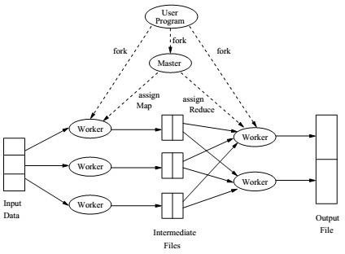

Figure 4.4: Overview of the execution of a MapReduce program

* 1. The Reduce task takes the output from the Map as an input and combines those data tuples (key- value pairs) into a smaller set of tuples.
  2. The reduce task is always performed after the map job.

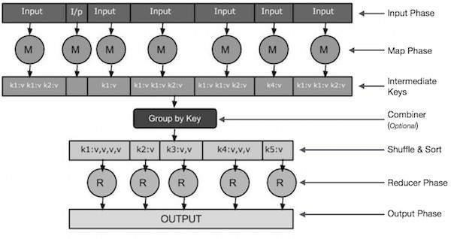

Figure 4.5: Reduce job

* + **Input Phase** − Here we have a Record Reader that translates each record in an input file and sends the parsed data to the mapper in the form of key-value pairs.
  + **Map** − Map is a user-defined function, which takes a series of key-value pairs and processes each one of them to generate zero or more key-value pairs.
  + **Intermediate Keys** − they key-value pairs generated by the mapper are known as intermediate keys.
  + **Combiner** − A combiner is a type of local Reducer that groups similar data from the map phase into identifiable sets. It takes the intermediate keys from the mapper as input and applies a user-defined code to aggregate the values in a small scope of one mapper. It is not a part of the main MapReduce algorithm; it is optional.
  + **Shuffle and Sort** − The Reducer task starts with the Shuffle and Sort step. It downloads the grouped key-value pairs onto the local machine, where the Reducer is running. The individual key-value pairs are sorted by key into a larger data list. The data list groups the equivalent keys together so that their values can be iterated easily in the Reducer task.
  + **Reducer** − The Reducer takes the grouped key-value paired data as input and runs a Reducer function on each one of them. Here, the data can be aggregated, filtered, and combined in a number of ways, and it requires a wide range of processing. Once the execution is over, it gives zero or more key- value pairs to the final step.
  + **Output Phase** − In the output phase, we have an output formatter that translates the final key-value pairs from the Reducer function and writes them onto a file using a record writer.
  1. The MapReduce phase

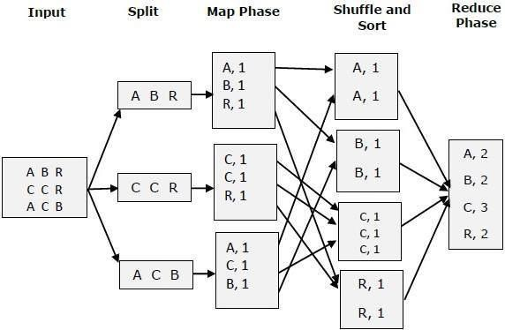

Figure 46 The MapReduce Phase

## MapReduce-Example

Twitter receives around 500 million tweets per day, which is nearly 3000 tweets per second. The following illustration shows how Tweeter manages its tweets with the help of MapReduce.

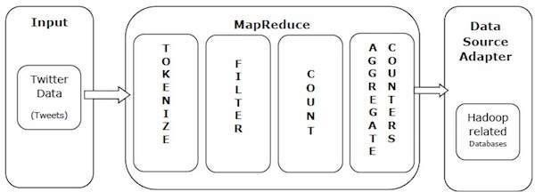

Figure4.7: Example

1. **Tokenize** − Tokenizes the tweets into maps of tokens and writes them as key-value pairs.
2. **Filter** − Filters unwanted words from the maps of tokens and writes the filtered maps as key- value pairs.
3. **Count** − Generates a token counter per word.
4. **Aggregate Counters** − Prepares an aggregate of similar counter values into small manageable units.

## MapReduce – Algorithm

The MapReduce algorithm contains two important tasks, namely Map and Reduce.

* 1. The map task is done by means of Mapper Class

Mapper class takes the input, tokenizes it, maps and sorts it. The output of Mapper class is used as input by Reducer class, which in turn searches matching pairs and reduces them.

* 1. The reduce task is done by means of Reducer Class.

MapReduce implements various mathematical algorithms to divide a task into small parts and assign them to multiple systems. In technical terms, MapReduce algorithm helps in sending the Map & Reduce tasks to appropriate servers in a cluster.

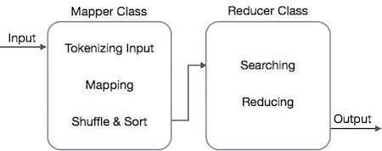

Figure 4.8: The MapReduce Class

## Coping With Node Failures

1. The worst thing that can happen is that the compute node at which the Master is executing fails. In this case, the entire MapReduce job must be restarted.
2. But only this one node can bring the entire process down; other failures will be managed by the Master, and the MapReduce job will complete eventually.
3. Suppose the compute node at which a Map worker resides fails. This failure will be detected by the Master, because it periodically pings the Worker processes.
4. All the Map tasks that were assigned to this Worker will have to be redone, even if they had completed. The reason for redoing completed Map asks is that their output destined for the Reduce tasks resides at that compute node, and is now unavailable to the Reduce tasks.
5. The Master sets the status of each of these Map tasks to idle and will schedule them on a Worker when one becomes available.
6. The Master must also inform each Reduce task that the location of its input from that Map task has changed. Dealing with a failure at the node of a Reduce worker is simpler.
7. The Master simply sets the status of its currently executing Reduce tasks to idle. These will be rescheduled on another reduce worker later.

# UNIT V INTRODUCTION TO PIG AND HIVE

Pig raises the level of abstraction for processing large datasets. MapReduce allows you the programmer to specify a map function followed by a reduce function, but working out how to fit your data processing into this pattern, which often requires multiple MapReduce stages, can be a challenge. With Pig, the data structures are much richer, typically being multivalued and nested; and the set of transformations you can apply to the data are much more powerful they include joins, for example, which are not for the faint of heart in MapReduce.

Pig is made up of two pieces:

* + The language used to express data flows, called *Pig Latin*.
  + The execution environment to run Pig Latin programs. There are currently two environments: local execution in a single JVM and distributed execution on a Ha- doop cluster.

A Pig Latin program is made up of a series of operations, or transformations, that are applied to the input data to produce output. Taken as a whole, the operations describe a data flow, which the Pig execution environment translates into an executable repre- sentation and then runs. Under the covers, Pig turns the transformations into a series of MapReduce jobs, but as a programmer you are mostly unaware of this, which allows you to focus on the data rather than the nature of the execution.

Pig is a scripting language for exploring large datasets. One criticism of MapReduce is that the development cycle is very long. Writing the mappers and reducers, compiling and packaging the code, submitting the job(s), and retrieving the results is a time- consuming business, and even with Streaming, which removes the compile and package step, the experience is still involved. Pig’s sweet spot is its ability to process terabytes of data simply by issuing a half- dozen lines of Pig Latin from the console. Indeed, it was created at Yahoo! to make it easier for researchers and engineers to mine the huge datasets there. Pig is very supportive of a programmer writing a query, since it provides several commands for introspecting the data structures in your program, as it is written. Even more useful, it can perform a sample run on a representative subset of your input data, so you can see whether there are errors in the processing before unleashing it on the full dataset.

Pig was designed to be extensible. Virtually all parts of the processing path are cus- tomizable: loading, storing, filtering, grouping, and joining can all be altered by user- defined functions (UDFs). These functions operate on Pig’s nested data model, so they can integrate very deeply with Pig’s operators. As another benefit, UDFs tend to be more reusable than the libraries developed for writing MapReduce programs.

Pig isn’t suitable for all data processing tasks, however. Like MapReduce, it is designed for batch processing of data. If you want to perform a query that touches only a small amount of data in a large dataset, then Pig will not perform well, since it is set up to scan the whole dataset, or at least large portions of it.

In some cases, Pig doesn’t perform as well as programs written in MapReduce. How- ever, the gap is narrowing with each release, as the Pig team implements sophisticated algorithms for implementing Pig’s relational operators. It’s fair to say that unless you are willing to invest a lot of effort optimizing Java MapReduce code, writing queries in Pig Latin will save you time.

# INSTALLING AND RUNNING PIG

Pig runs as a client-side application. Even if you want to run Pig on a Hadoop cluster, there is nothing extra to install on the cluster: Pig launches jobs and interacts with HDFS (or other Hadoop filesystems) from your workstation.

Installation is straightforward. Java 6 is a prerequisite (and on Windows, you will need Cygwin). Download a stable release from *<http://pig.apache.org/releases.html>*[,](http://pig.apache.org/releases.html) and unpack the tarball in a suitable place on your workstation:

% **tar xzf pig-*x.y.z*.tar.gz**

It’s convenient to add Pig’s binary directory to your command-line path. For example:

## % export PIG_INSTALL=/home/tom/pig-*x.y.z*

% **export PATH=$PATH:$PIG_INSTALL/bin**

You also need to set the JAVA_HOME environment variable to point to a suitable Java installation.

Try typing pig -help to get usage instructions.

# EXECUTION TYPES

Pig has two execution types or modes: local mode and MapReduce mode.

# LOCAL MODE

In local mode, Pig runs in a single JVM and accesses the local filesystem. This mode is suitable only for small datasets and when trying out Pig.

The execution type is set using the -x or -exectype option. To run in local mode, set the option to local:

## % pig -x local

grunt>

This starts Grunt, the Pig interactive shell, which is discussed in more detail shortly.

# MAPREDUCE MODE

In MapReduce mode, Pig translates queries into MapReduce jobs and runs them on a Hadoop cluster. The cluster may be a pseudo- or fully distributed cluster. MapReduce mode (with a fully distributed cluster) is what you use when you want to run Pig on large datasets.

To use MapReduce mode, you first need to check that the version of Pig you down- loaded is compatible with the version of Hadoop you are using. Pig releases will only work against particular versions of Hadoop; this is documented in the release notes.

Pig honors the HADOOP_HOME environment variable for finding which Hadoop client to run. However if it is not set, Pig will use a bundled copy of the Hadoop libraries. Note that these may not match the version of Hadoop running on your cluster, so it is best to explicitly set HADOOP_HOME.

Next, you need to point Pig at the cluster’s namenode and jobtracker. If the installation of Hadoop at HADOOP_HOME is already configured for this, then there is nothing more to do. Otherwise, you can set HADOOP_CONF_DIR to a directory containing the Hadoop site file (or files) that define fs.default.name and mapred.job.tracker.

Alternatively, you can set these two properties in the *pig.properties* file in Pig’s *conf* directory (or the directory specified by PIG_CONF_DIR). Here’s an example for a pseudo- distributed setup:

fs.default.name=hdfs://localhost/ mapred.job.tracker=localhost:8021

Once you have configured Pig to connect to a Hadoop cluster, you can launch Pig, setting the

-x option to mapreduce, or omitting it entirely, as MapReduce mode is the default:

% **pig**

2012-01-18 20:23:05,764 [main] INFO org.apache.pig.Main - Logging error message s to: /private/tmp/pig_1326946985762.log

2012-01-18 20:23:06,009 [main] INFO

org.apache.pig.backend.hadoop.executionengi ne.HExecutionEngine - Connecting to hadoop file system at: hdfs://localhost/ 2012-01-18 20:23:06,274 [main] INFO org.apache.pig.backend.hadoop.executionengi ne.HExecutionEngine - Connecting to map-reduce job tracker at: localhost:8021 grunt>

As you can see from the output, Pig reports the filesystem and jobtracker that it has connected to.

# RUNNING PIG PROGRAMS

There are three ways of executing Pig programs, all of which work in both local and MapReduce mode:

*Script*

Pig can run a script file that contains Pig commands. For example, pig script.pig runs the commands in the local file *script.pig*. Alternatively, for very short scripts, you can use the -e option to run a script specified as a string on the command line.

*Grunt*

Grunt is an interactive shell for running Pig commands. Grunt is started when no file is specified for Pig to run, and the -e option is not used. It is also possible to run Pig scripts from within Grunt using run and exec.

*Embedded*

You can run Pig programs from Java using the PigServer class, much like you can use JDBC to run SQL programs from Java. For programmatic access to Grunt, use PigRunner.

Pig Latin Editors

PigPen is an Eclipse plug-in that provides an environment for developing Pig programs. It includes a Pig script text editor, an example generator (equivalent to the ILLUS- TRATE command), and a button for running the script on a Hadoop cluster. There is also an operator graph window, which shows a script in graph form, for visualizing the data flow. For full installation and usage instructions, please refer to the Pig wiki at *<https://cwiki.apache.org/confluence/display/PIG/PigTools>*[.](https://cwiki.apache.org/confluence/display/PIG/PigTools)

There are also Pig Latin syntax highlighters for other editors, including Vim and Text- Mate. Details are available on the Pig wiki.

## An Example

Let’s look at a simple example by writing the program to calculate the maximum recorded temperature by year for the weather dataset in Pig Latin (just like we did using MapReduce. The complete program is only a few lines long:

-- max_temp.pig: Finds the maximum temperature by year records = LOAD 'input/ncdc/micro-tab/sample.txt'

AS (year:chararray, temperature:int, quality:int); filtered_records = FILTER records BY temperature != 9999 AND

(quality == 0 OR quality == 1 OR quality == 4 OR quality == 5 OR quality == 9); grouped_records = GROUP filtered_records BY year;

max_temp = FOREACH grouped_records GENERATE group, MAX(filtered_records.temperature);

DUMP max_temp;

To explore what’s going on, we’ll use Pig’s Grunt interpreter, which allows us to enter lines and interact with the program to understand what it’s doing. Start up Grunt in local mode, then enter the first line of the Pig script:

## grunt> records = LOAD 'input/ncdc/micro-tab/sample.txt'

>> **AS (year:chararray, temperature:int, quality:int);**

For simplicity, the program assumes that the input is tab-delimited text, with each line having just year, temperature, and quality fields. (Pig actually has more flexibility than this with regard to the input formats it accepts, as you’ll see later.) This line describes the input data we want to process. The year:chararray notation describes the field’s name and type; a chararray is like a Java string, and an int is like a Java int. The LOAD operator takes a URI argument; here we are just using a local file, but we could refer to an HDFS URI. The AS clause (which is optional) gives the fields names to make it convenient to refer to them in subsequent statements.

# PIG LATIN

This section gives an informal description of the syntax and semantics of the Pig Latin programming language.3 It is not meant to offer a complete reference to the language,4 but there should be enough here for you to get a good understanding of Pig Latin’s constructs.

# STRUCTURE

A Pig Latin program consists of a collection of statements. A statement can be thought of as an operation, or a command.5 For example, a GROUP operation is a type of statement:

The command to list the files in a Hadoop filesystem is another example of a statement: ls /

Statements are usually terminated with a semicolon, as in the example of the GROUP statement. In fact, this is an example of a statement that must be terminated with a semicolon: it is a syntax error to omit it. The ls command, on the other hand, does not have to be terminated with a semicolon. As a general guideline, statements or com- mands for interactive use in Grunt do not need the terminating semicolon. This group includes the interactive Hadoop commands, as well as the diagnostic operators like DESCRIBE. It’s never an error to add a terminating semicolon, so if in doubt, it’s sim- plest to add one.

Statements that have to be terminated with a semicolon can be split across multiple lines for readability:

records = LOAD 'input/ncdc/micro-tab/sample.txt'

AS (year:chararray, temperature:int, quality:int);

Pig Latin has two forms of comments. Double hyphens are single-line comments. Everything from the first hyphen to the end of the line is ignored by the Pig Latin interpreter:

-- My program

DUMP A; -- What's in A?

C-style comments are more flexible since they delimit the beginning and end of the comment block with /* and */ markers. They can span lines or be embedded in a single line:

/*

* Description of my program spanning
* multiple lines.

*/

A = LOAD 'input/pig/join/A'; B = LOAD 'input/pig/join/B'; C = JOIN A BY $0, /* ignored */ B BY $1; DUMP C;

Pig Latin has a list of keywords that have a special meaning in the language and cannot be used as identifiers. These include the operators (LOAD, ILLUSTRATE), commands (cat, ls), expressions (matches, FLATTEN), and functions (DIFF, MAX)—all of which are covered in the following sections.

Pig Latin has mixed rules on case sensitivity. Operators and commands are not case- sensitive (to make interactive use more forgiving); however, aliases and function names are case- sensitive.

# TYPES

So far you have seen some of the simple types in Pig, such as int and chararray. Here we will discuss Pig’s built-in types in more detail.

Pig hasfournumerictypes: int, long, float, anddouble, whichareidenticaltotheir Java counterparts. There is also a byte array type, like Java’s byte array type for representing a blob of binary data, and char array, which, like java.lang. String, represents textual data in UTF-16 format, although it can be loaded or stored in UTF-8 format. Pig does not have types corresponding to Java’s boolean, byte, short, or char primitive types. These are all easily represented using Pig’s int type, orchar array forchar.

The numeric, textual, and binary types are simple atomic types. Pig Latin also has three complex types for representing nested structures: tuple, bag, and map.

The complex types are usually loaded from files or constructed using relational operators. Be aware, however, that the literal form is used when a constant value is created from within a Pig Latin program. The raw form in a file is usually different when using the standard Pig

Storage loader. For example, the representation in a file of the bag would be

{(1,pomegranate),(2)} (note the lack of quotes), and with a suitable schema, this would be loaded as a relation with a single field and row, whose value was the bag.

Pig provides built-in functions TOTUPLE, TOBAG and TOMAP, which are used for turning expressions into tuples, bags and maps.

Although relations and bags are conceptually the same (an unordered collection of tuples), in practice Pig treats them slightly differently. A relation is a top-level construct, whereas a bag has to be contained in a relation. Normally, you don’t have to worry about this, but there are a few restrictions that can trip up the uninitiated. For example, it’s not possible to create a relation from a bag literal. So the following statement fails:

A = {(1,2),(3,4)}; -- Error

The simplest workaround in this case is to load the data from a file using the LOAD statement.

As another example, you can’t treat a relation like a bag and project a field into a new relation ($0 refers to the first field of A, using the positional notation):

B = A.$0;

Instead, you have to use a relational operator to turn the relation A into relation B: B = FOREACH A GENERATE $0;

It’s possible that a future version of Pig Latin will remove these inconsistencies and treat relations and bags in the same way.

Functions

Functions in Pig come in four types:

*Eval function*

A function that takes one or more expressions and returns another expression. An example of a built-in eval function is MAX, which returns the maximum value of the entries in a bag. Some eval functions are *aggregate functions*, which means they operate on a bag of data to produce a scalar value; MAX is an example of an aggregate function. Furthermore, many aggregate functions are *algebraic*, which means that the result of the function may be calculated incrementally. In MapReduce terms, algebraic functions make use of the combiner and are much more efficient to calculate MAX is an algebraic function, whereas a function to calculate the median of a collection of values is an example of a function that is not algebraic.

*Filter function*

A special type of eval function that returns a logical boolean result. As the name suggests, filter functions are used in the FILTER operator to remove unwanted rows. They can also be used in other relational operators that take boolean con- ditions and, in general, expressions using boolean or conditional expressions. An example of a built-in filter function is IsEmpty, which tests whether a bag or a map contains any items.

*Load function*

A function that specifies how to load data into a relation from external storage.

*Store function*

A function that specifies how to save the contents of a relation to external storage. Often, load and store functions are implemented by the same type. For example, PigStorage, which loads data from delimited text files, can store data in the same format.

Pig comes with a collection of built-in functions. The complete list of built-in functions, which includes a large number of standard math and string functions, can be found in the documentation for each Pig release.

If the function you need is not available, you can write your own. Before you do that, however, have a look in the *Piggy Bank*, a repository of Pig functions shared by the Pig community. For example, there are load and store functions in the Piggy Bank for Avro data files, CSV files, Hive RCFiles, Sequence Files, and XML files. The Pig website has instructions on how to browse and obtain the Piggy Bank functions. If the Piggy Bank doesn’t have what you need, you can write your own function (and if it is sufficiently general, you might consider contributing it to the Piggy Bank so that others can benefit from it, too). These are known as *user-defined functions*, or UDFs.

# DATA PROCESSING OPERATORS

## Loading and Storing Data

Throughout this chapter, we have seen how to load data from external storage for processing in Pig. Storing the results is straightforward, too. Here’s an example of using PigStorage to store tuples as plain-text values separated by a colon character:

## grunt> STORE A INTO 'out' USING PigStorage(':');

grunt> **cat out** Joe:cherry:2 Ali:apple:3 Joe:banana:2 Eve:apple:7

Filtering Data

Once you have some data loaded into a relation, the next step is often to filter it to remove the data that you are not interested in. By filtering early in the processing pipe- line, you minimize the amount of data flowing through the system, which can improve efficiency.

# FOREACH...GENERATE

We have already seen how to remove rows from a relation using the FILTER operator with simple expressions and a UDF. The FOREACH...GENERATE operator is used to act on every row in a relation. It can be used to remove fields or to generate new ones. In this example, we do both:

grunt> **DUMP A;** (Joe,cherry,2) (Ali,apple,3) (Joe,banana,2) (Eve,apple,7) grunt> **B = FOREACH A GENERATE $0, $2+1, 'Constant';**

grunt> **DUMP B;** (Joe,3,Constant) (Ali,4,Constant) (Joe,3,Constant) (Eve,8,Constant)

Here we have created a new relation B with three fields. Its first field is a projection of the first field ($0) of A. B’s second field is the third field of A ($2) with one added to it. B’s third field is a constant field (every row in B has the same third field) with the chararray value Constant.

The FOREACH...GENERATE operator has a nested form to support more complex processing. In the following example, we compute various statistics for the weather dataset:

-- year_stats.pig REGISTER pig-examples.jar;

DEFINE isGood com.hadoopbook.pig.IsGoodQuality(); records = LOAD 'input/ncdc/all/19{1,2,3,4,5}0*'

USING com.hadoopbook.pig.CutLoadFunc('5-10,11-15,16-19,88-92,93-93')

AS (usaf:chararray, wban:chararray, year:int, temperature:int, quality:int); grouped_records = GROUP records BY year PARALLEL 30;

year_stats = FOREACH grouped_records { uniq_stations = DISTINCT records.usaf; good_records = FILTER records BY isGood(quality);

GENERATE FLATTEN(group), COUNT(uniq_stations) AS station_count, COUNT(good_records) AS good_record_count, COUNT(records) AS record_count;

}

DUMP year_stats;

Using the cut UDF we developed earlier, we load various fields from the input dataset into the records relation. Next we group records by year. Notice the PARALLEL key- word for setting the number of reducers to use; this is vital when running on a cluster. Then we process each group using a nested FOREACH...GENERATE operator. The first nested statement creates a relation for the distinct USAF identifiers for stations using the DISTINCT operator. The second nested statement creates a relation for the

records with “good” readings using the FILTER operator and a UDF. The final nested statement is a GENERATE statement (a nested FOREACH...GENERATE must always have a GENERATE statement as the last nested statement) that generates the summary fields of interest using the grouped records, as well as the relations created in the nested block.

Running it on a few years of data, we get the following:

(1920,8L,8595L,8595L) (1950,1988L,8635452L,8641353L) (1930,121L,89245L,89262L) (1910,7L,7650L,7650L) (1940,732L,1052333L,1052976L)

The fields are year, number of unique stations, total number of good readings, and total number of readings. We can see how the number of weather stations and readings grew over time.

# STREAM

The STREAM operator allows you to transform data in a relation using an external program or script. It is named by analogy with Hadoop Streaming, which provides a similar capability for MapReduce.

STREAM can use built-in commands with arguments. Here is an example that uses the Unix cut command to extract the second field of each tuple in A. Note that the com- mand and its arguments are enclosed in backticks:

## grunt> C = STREAM A THROUGH `cut -f 2`;

grunt> **DUMP C;** (cherry) (apple) (banana) (apple)

The STREAM operator uses PigStorage to serialize and deserialize relations to and from the program’s standard input and output streams. Tuples in A are converted to tab- delimited lines that are passed to the script. The output of the script is read one line at a time and split on tabs to create new tuples for the output relation C. You can provide a custom serializer and deserializer, which implement PigToStream and StreamToPig respectively (both in the org.apache.pig package), using the DEFINE command.

Pig streaming is most powerful when you write custom processing scripts. The follow- ing Python script filters out bad weather records:

#!/usr/bin/env python import re import sys

for line in sys.stdin:

(year, temp, q) = line.strip().split()

if (temp != "9999" and re.match("[01459]", q)):

print "%s\t%s" % (year, temp)

To use the script, you need to ship it to the cluster. This is achieved via a DEFINE clause, which also creates an alias for the STREAM command. The STREAM statement can then refer to the alias, as the following Pig script shows:

-- max_temp_filter_stream.pig

DEFINE is_good_quality `is_good_quality.py`

SHIP ('ch11/src/main/python/is_good_quality.py'); records = LOAD 'input/ncdc/micro- tab/sample.txt'

AS (year:chararray, temperature:int, quality:int); filtered_records = STREAM records THROUGH is_good_quality

AS (year:chararray, temperature:int); grouped_records = GROUP filtered_records BY year; max_temp = FOREACH grouped_records GENERATE group,

MAX(filtered_records.temperature); DUMP max_temp; Grouping and Joining Data

Joining datasets in MapReduce takes some work on the part of the, whereas Pig has very good built-in support for join operations, making it much more approachable. Since the large datasets that are suitable for analysis by Pig (and MapReduce in general) are not normalized, joins are used more infrequently in Pig than they are in SQL.

# JOIN

Let’s look at an example of an inner join. Consider the relations A and B: grunt> **DUMP A;**

(2,Tie)

(4,Coat)

(3,Hat)

(1,Scarf) grunt> **DUMP B;** (Joe,2) (Hank,4)

(Ali,0)

(Eve,3)

(Hank,2)

We can join the two relations on the numerical (identity) field in each: grunt> **C = JOIN A BY $0, B BY $1;**

grunt> **DUMP C;**

(2,Tie,Joe,2)

(2,Tie,Hank,2)

(3,Hat,Eve,3)

(4,Coat,Hank,4)

This is a classic inner join, where each match between the two relations corresponds to a row in the result. (It’s actually an equijoin since the join predicate is equality.) The result’s fields are made up of all the fields of all the input relations.

You should use the general join operator if all the relations being joined are too large to fit in memory. If one of the relations is small enough to fit in memory, there is a special type of join called a *fragment replicate join*, which is implemented by distributing the small input to all the mappers and performing a map-side join using an in-memory lookup table against the (fragmented) larger relation. There is a special syntax for telling Pig to use a fragment replicate join:8

## grunt> C = JOIN A BY $0, B BY $1 USING "replicated";

The first relation must be the large one, followed by one or more small ones (all of which must fit in memory).

Pig also supports outer joins using a syntax that is similar to SQL’s. For example: grunt> **C = JOIN A BY $0 LEFT OUTER, B BY $1;**

grunt> **DUMP C;**

(1,Scarf,,)

(2,Tie,Joe,2)

(2,Tie,Hank,2)

(3,Hat,Eve,3)

(4,Coat,Hank,4)

# COGROUP

JOIN always gives a flat structure: a set of tuples. The COGROUP statement is similar to JOIN, but creates a nested set of output tuples. This can be useful if you want to exploit the structure in subsequent statements:

## grunt> D = COGROUP A BY $0, B BY $1;

grunt> **DUMP D;**

(0,{},{(Ali,0)})

(1,{(1,Scarf)},{}) (2,{(2,Tie)},{(Joe,2),(Hank,2)}) (3,{(3,Hat)},{(Eve,3)})

(4,{(4,Coat)},{(Hank,4)})

COGROUP generates a tuple for each unique grouping key. The first field of each tuple is the key, and the remaining fields are bags of tuples from the relations with a matching key. The first bag contains the matching tuples from relation A with the same key. Similarly, the second bag contains the matching tuples from relation B with the same key.

If for a particular key a relation has no matching key, then the bag for that relation is empty. For example, since no one has bought a scarf (with ID 1), the second bag in the tuple for that row is empty. This is an example of an outer join, which is the default type for COGROUP. It can be made explicit using the OUTER keyword, making this COGROUP statement the same as the previous one:

D = COGROUP A BY $0 **OUTER**, B BY $1 **OUTER**;

You can suppress rows with empty bags by using the INNER keyword, which gives the COGROUP inner join semantics. The INNER keyword is applied per relation, so the following only suppresses rows when relation A has no match (dropping the unknown product 0 here):

## grunt> E = COGROUP A BY $0 INNER, B BY $1;

grunt> **DUMP E;** (1,{(1,Scarf)},{}) (2,{(2,Tie)},{(Joe,2),(Hank,2)}) (3,{(3,Hat)},{(Eve,3)})

(4,{(4,Coat)},{(Hank,4)})

We can flatten this structure to discover who bought each of the items in relation A: grunt> **F = FOREACH E GENERATE FLATTEN(A), B.$0;**

grunt> **DUMP F;** (1,Scarf,{}) (2,Tie,{(Joe),(Hank)}) (3,Hat,{(Eve)})

(4,Coat,{(Hank)})

Using a combination of COGROUP, INNER, and FLATTEN (which removes nesting) it’s possible to simulate an (inner) JOIN:

## grunt> G = COGROUP A BY $0 INNER, B BY $1 INNER;

grunt> **H = FOREACH G GENERATE FLATTEN($1), FLATTEN($2);**

grunt> **DUMP H;**

(2,Tie,Joe,2)

(2,Tie,Hank,2)

(3,Hat,Eve,3)

(4,Coat,Hank,4)

This gives the same result as JOIN A BY $0, B BY $1.

If the join key is composed of several fields, you can specify them all in the BY clauses of the JOIN or COGROUP statement. Make sure that the number of fields in each BY clause is the same.

Here’s another example of a join in Pig, in a script for calculating the maximum tem- perature for every station over a time period controlled by the input:

-- max_temp_station_name.pig REGISTER pig-examples.jar; DEFINE isGood com.hadoopbook.pig.IsGoodQuality();

stations = LOAD 'input/ncdc/metadata/stations-fixed-width.txt' USING com.hadoopbook.pig.CutLoadFunc('1-6,8-12,14-42')

AS (usaf:chararray, wban:chararray, name:chararray);

trimmed_stations = FOREACH stations GENERATE usaf, wban, com.hadoopbook.pig.Trim(name);

records = LOAD 'input/ncdc/all/191*'

USING com.hadoopbook.pig.CutLoadFunc('5-10,11-15,88-92,93-93') AS (usaf:chararray, wban:chararray, temperature:int, quality:int);

filtered_records = FILTER records BY temperature != 9999 AND isGood(quality); grouped_records = GROUP filtered_records BY (usaf, wban) PARALLEL 30; max_temp = FOREACH grouped_records GENERATE FLATTEN(group),

MAX(filtered_records.temperature);

max_temp_named = JOIN max_temp BY (usaf, wban), trimmed_stations BY (usaf, wban) PARALLEL 30;

max_temp_result = FOREACH max_temp_named GENERATE $0, $1, $5, $2; STORE max_temp_result INTO 'max_temp_by_station';

We use the cut UDF we developed earlier to load one relation holding the station IDs (USAF and WBAN identifiers) and names, and one relation holding all the weather records, keyed by station ID. We group the filtered weather records by station ID and aggregate by maximum temperature, before joining with the stations. Finally, we project out the fields we want in the final result: USAF, WBAN, station name, maxi- mum temperature.

This query could be made more efficient by using a fragment replicate join, as the station metadata is small.

# CROSS

Pig Latin includes the cross-product operator (also known as the cartesian product), which joins every tuple in a relation with every tuple in a second relation (and with every tuple in further relations if supplied). The size of the output is the product of the size of the inputs, potentially making the output very large:

grunt> **I = CROSS A, B;**

grunt> **DUMP I;**

(2,Tie,Joe,2)

(2,Tie,Hank,4)

(2,Tie,Ali,0)

(2,Tie,Eve,3)

(2,Tie,Hank,2)

(4,Coat,Joe,2)

(4,Coat,Hank,4)

(4,Coat,Ali,0)

(4,Coat,Eve,3)

(4,Coat,Hank,2)

(3,Hat,Joe,2)

(3,Hat,Hank,4)

(3,Hat,Ali,0)

(3,Hat,Eve,3)

(3,Hat,Hank,2)

(1,Scarf,Joe,2)

(1,Scarf,Hank,4)

(1,Scarf,Ali,0)

(1,Scarf,Eve,3)

(1,Scarf,Hank,2)

When dealing with large datasets, you should try to avoid operations that generate intermediate representations that are quadratic (or worse) in size. Computing the cross- product of the whole input dataset is rarely needed, if ever.

For example, at first blush one might expect that calculating pairwise document simi- larity in a corpus of documents would require every document pair to be generated befor e calculating their similarity. However, if one starts with the insight that most document pairs have a similarity score of zero (that is, they are unrelated), then we can find a way to a better algorithm.

In this case, the key idea is to focus on the entities that we are using to calculate similarity (terms in a document, for example) and make them the center of the algorithm. In practice, we also remove terms that don’t help discriminate between documents (stop- words), and this reduces the problem space still further. Using this technique to analyze a set of roughly one million

(106) documents generates in the order of one billion

(109) intermediate pairs,9 rather than the one trillion (1012) produced by the naive approach (generating the cross-product of the input) or the approach with no stopword removal. **GROUP**

Although COGROUP groups the data in two or more relations, the GROUP statement groups the data in a single relation. GROUP supports grouping by more than equality of keys: you can use an expression or user-defined function as the group key. For ex- ample, consider the following relation A:

grunt> **DUMP A;** (Joe,cherry) (Ali,apple) (Joe,banana) (Eve,apple) Let’s group by the number of characters in the second field:

grunt> **B = GROUP A BY SIZE($1);**

grunt> **DUMP B;**

(5,{(Ali,apple),(Eve,apple)})

(6,{(Joe,cherry),(Joe,banana)})

GROUP creates a relation whose first field is the grouping field, which is given the alias group. The second field is a bag containing the grouped fields with the same schema as the original relation (in this case, A).

There are also two special grouping operations: ALL and ANY. ALL groups all the tuples in a relation in a single group, as if the GROUP function was a constant:

grunt> **C = GROUP A ALL;**

grunt> **DUMP C;**

(all,{(Joe,cherry),(Ali,apple),(Joe,banana),(Eve,apple)})

Note that there is no BY in this form of the GROUP statement. The ALL grouping is commonly used to count the number of tuples in a relation.

The ANY keyword is used to group the tuples in a relation randomly, which can be useful for sampling.

## Sorting Data

Relations are unordered in Pig. Consider a relation A:

grunt> **DUMP A;**

(2,3)

(1,2)

(2,4)

There is no guarantee which order the rows will be processed in. In particular, when retrieving the contents of A using DUMP or STORE, the rows may be written in any order. If you want to impose an order on the output, you can use the ORDER operator to sort a relation by one or more fields. The default sort order compares fields of the same type using the natural ordering,

and different types are given an arbitrary, but deterministic, ordering (a tuple is always “less than” a bag, for example).

The following example sorts A by the first field in ascending order and by the second field in descending order:

grunt> **B = ORDER A BY $0, $1 DESC;**

grunt> **DUMP B;**

(1,2)

(2,4)

(2,3)

Any further processing on a sorted relation is not guaranteed to retain its order. For example: grunt> **C = FOREACH B GENERATE *;**

Even though relation C has the same contents as relation B, its tuples may be emitted in any order by a DUMP or a STORE. It is for this reason that it is usual to perform the ORDER operation just before retrieving the output.

The LIMIT statement is useful for limiting the number of results, as a quick and dirty way to get a sample of a relation; prototyping (the ILLUSTRATE command) should be preferred for generating more representative samples of the data. It can be used imme- diately after the ORDER statement to retrieve the first *n* tuples. Usually, LIMIT will select any *n* tuples from a relation, but when used immediately after an ORDER state- ment, the order is retained (in an exception to the rule that processing a relation does not retain its order):

grunt> **D = LIMIT B 2;**

grunt> **DUMP D;**

(1,2)

(2,4)

If the limit is greater than the number of tuples in the relation, all tuples are returned (so LIMIT has no effect).

Using LIMIT can improve the performance of a query because Pig tries to apply the limit as early as possible in the processing pipeline, to minimize the amount of data that needs to be processed. For this reason, you should always use LIMIT if you are not interested in the entire output.

## Combining and Splitting Data

Sometimes you have several relations that you would like to combine into one. For this, the UNION statement is used. For example:

grunt> **DUMP A;**

(2,3)

(1,2)

(2,4)

grunt> **DUMP B;**

(z,x,8)

(w,y,1)

grunt> **C = UNION A, B;**

grunt> **DUMP C;**

(2,3)

(1,2)

(2,4)

(z,x,8)

(w,y,1)

C is the union of relations A and B, and since relations are unordered, the order of the tuples in C is undefined. Also, it’s possible to form the union of two relations with different schemas or with different numbers of fields, as we have done here. Pig attempts to merge the schemas from the relations that UNION is operating on. In this case, they are incompatible, so C has no schema:

grunt> **DESCRIBE A;** A: {f0: int,f1: int} grunt> **DESCRIBE B;** B: {f0: chararray,f1: chararray,f2: int} grunt> **DESCRIBE C;** Schema for C unknown.

If the output relation has no schema, your script needs to be able to handle tuples that vary in the number of fields and/or types.

The SPLIT operator is the opposite of UNION; it partitions a relation into two or more relations..

## Pig in Practice

There are some practical techniques that are worth knowing about when you are developing and running Pig programs. This section covers some of them.

## Parallelism

When running in MapReduce mode it’s important that the degree of parallelism matches the size of the dataset. By default, Pig will sets the number of reducers by looking at the size of the input, and using one reducer per 1GB of input, up to a max- imum of 999 reducers. You can override these parameters by setting pig.exec.reduc ers.bytes.per.reducer (the default is 1000000000 bytes) and pig.exec.reducers.max (default 999).

To explictly set the number of reducers you want for each job, you can use a PARALLEL clause for operators that run in the reduce phase. These include all the grouping and joining operators (GROUP, COGROUP, JOIN, CROSS), as well as DISTINCT and ORDER. The following line sets the number of reducers to 30 for the GROUP:

grouped_records = GROUP records BY year PARALLEL 30;

Alternatively, you can set the default_parallel option, and it will take effect for all subsequent jobs:

grunt> **set default_parallel 30**

A good setting for the number of reduce tasks is slightly fewer than the number of reduce slots in the cluster.

The number of map tasks is set by the size of the input (with one map per HDFS block) and is not affected by the PARALLEL clause.

## Parameter Substitution

If you have a Pig script that you run on a regular basis, then it’s quite common to want to be able to run the same script with different parameters. For example, a script that runs daily may use the date to determine which input files it runs over. Pig supports *parameter substitution*, where parameters in the script are substituted with values supplied at runtime. Parameters are denoted by identifiers prefixed with a $ character; for example, $input and

$output are used in the following script to specify the input and output paths:

-- max_temp_param.pig

records = LOAD '$input' AS (year:chararray, temperature:int, quality:int); filtered_records = FILTER records BY temperature != 9999 AND

(quality == 0 OR quality == 1 OR quality == 4 OR quality == 5 OR quality == 9); grouped_records = GROUP filtered_records BY year;

max_temp = FOREACH grouped_records GENERATE group, MAX(filtered_records.temperature);

STORE max_temp into '$output';

Parameters can be specified when launching Pig, using the -param option, one for each parameter:

% **pig -param input=/user/tom/input/ncdc/micro-tab/sample.txt \**

* **-param output=/tmp/out \**
* **ch11/src/main/pig/max_temp_param.pig**

You can also put parameters in a file and pass them to Pig using the -param_file option. For example, we can achieve the same result as the previous command by placing the parameter definitions in a file:

# Input file

input=/user/tom/input/ncdc/micro-tab/sample.txt # Output file output=/tmp/out

The *pig* invocation then becomes:

## % pig -param_file ch11/src/main/pig/max_temp_param.param \

* **ch11/src/main/pig/max_temp_param.pig**

You can specify multiple parameter files using -param_file repeatedly. You can also use a combination of -param and -param_file options, and if any parameter is defined in both a parameter file and on the command line, the last value on the command line takes precedence.

# HIVE

In “Information Platforms and the Rise of the Data Scientist,”1 Jeff Hammerbacher describes Information Platforms as “the locus of their organization’s efforts to ingest, process, and generate information,” and how they “serve to accelerate the process of learning from empirical data.”

One of the biggest ingredients in the Information Platform built by Jeff’s team at Face- book was Hive, a framework for data warehousing on top of Hadoop. Hive grew from a need to manage and learn from the huge volumes of data that Facebook was producing every day from its burgeoning social network. After trying a few different systems, the team chose Hadoop for storage and processing, since it was cost-effective and met their scalability needs.2

Hive was created to make it possible for analysts with strong SQL skills (but meager Java programming skills) to run queries on the huge volumes of data that Facebook stored in HDFS. Today, Hive is a successful Apache project used by many organizations as a general-purpose, scalable data processing platform.

Of course, SQL isn’t ideal for every big data problem—it’s not a good fit for building complex machine learning algorithms, for example—but it’s great for many analyses, and it has the huge advantage of being very well known in the industry. What’s more, SQL is the *lingua franca* in business intelligence tools (ODBC is a common bridge, for example), so Hive is well placed to integrate with these products.

This chapter is an introduction to using Hive. It assumes that you have working knowl- edge of SQL and general database architecture; as we go through Hive’s features, we’ll often compare them to the equivalent in a traditional RDBMS.

**Installing Hive**

In normal use, Hive runs on your workstation and converts your SQL query into a series of MapReduce jobs for execution on a Hadoop cluster. Hive organizes data into tables, which provide a means for attaching structure to data stored in HDFS. Metadata— such as table schemas—is stored in a database called the *metastore*.

When starting out with Hive, it is convenient to run the metastore on your local ma- chine. In this configuration, which is the default, the Hive table definitions that you create will be local to your machine, so you can’t share them with other users. We’ll see how to configure a shared remote metastore, which is the norm in production environments.

Installation of Hive is straightforward. Java 6 is a prerequisite; and on Windows, you will need Cygwin, too. You also need to have the same version of Hadoop installed locally that your cluster is running.3 Of course, you may choose to run Hadoop locally, either in standalone or pseudo-distributed mode, while getting started with Hive. These options are all covered in Appendix A.

Download a release at *<http://hive.apache.org/releases.html>*[,](http://hive.apache.org/releases.html) and unpack the tarball in a suitable place on your workstation:

% **tar xzf hive-*x.y.z*-dev.tar.gz**

It’s handy to put Hive on your path to make it easy to launch:

## % export HIVE_INSTALL=/home/tom/hive-*x.y.z*-dev

% **export PATH=$PATH:$HIVE_INSTALL/bin**

Now type hive to launch the Hive shell:

% **hive** hive> **Running Hive**

In this section, we look at some more practical aspects of running Hive, including how to set up Hive to run against a Hadoop cluster and a shared metastore. In doing so, we’ll see Hive’s architecture in some detail.

## Configuring Hive

Hive is configured using an XML configuration file like Hadoop’s. The file is called *hive- site.xml* and is located in Hive’s *conf* directory. This file is where you can set prop- erties that you want to set every time you run Hive. The same directory contains *hive- default.xml*, which documents the properties that Hive exposes and their default values.

You can override the configuration directory that Hive looks for in *hive-site.xml* by passing the --config option to the *hive* command:

## % hive --config /Users/tom/dev/hive-conf

Note that this option specifies the containing directory, not *hive-site.xml* itself. It can be useful if you have multiple site files—for different clusters, say—that you switch between on a regular basis. Alternatively, you can set the HIVE_CONF_DIR environment variable to the configuration directory, for the same effect.

The *hive-site.xml* is a natural place to put the cluster connection details: you can specify the filesystem and jobtracker using the usual Hadoop properties, fs.default. name and mapred.job.tracker (see Appendix A for more details on configuring Hadoop). If not set, they default to the local filesystem and the local (in-process) job runner—just like they do in Hadoop—which is very handy when trying out Hive on small trial datasets. Metastore configuration settings are com- monly found in *hive-site.xml*, too.

Hive also permits you to set properties on a per-session basis, by passing the

-hiveconf option to the *hive* command. For example, the following command sets the cluster (to a pseudo-distributed cluster) for the duration of the session:

## % hive -hiveconf fs.default.name=localhost -hiveconf mapred.job.tracker=localhost:8021

If you plan to have more than one Hive user sharing a Hadoop cluster, then you need to make the directories that Hive uses writable by all users. The following commands will create the directories and set their permissions appropriately:

% **hadoop fs -mkdir /tmp**

% **hadoop fs -chmod a+w /tmp**

% **hadoop fs -mkdir /user/hive/warehouse**

% **hadoop fs -chmod a+w /user/hive/warehouse**

If all users are in the same group, then permissions g+w are sufficient on the warehouse directory.

You can change settings from within a session, too, using the SET command. This is useful for changing Hive or MapReduce job settings for a particular query. For example, the following command ensures buckets are populated according to the table definition.

## hive> SET hive.enforce.bucketing=true;

To see the current value of any property, use SET with just the property name: hive> **SET hive.enforce.bucketing;**

hive.enforce.bucketing=true

By itself, SET will list all the properties (and their values) set by Hive. Note that the list will not include Hadoop defaults, unless they have been explicitly overridden in one of the ways covered in this section. Use SET -v to list all the properties in the system, including Hadoop defaults.

There is a precedence hierarchy to setting properties. In the following list, lower num- bers take precedence over higher numbers:

1. The Hive SET command
2. The command line -hiveconf option
3. *hive-site.xml*
4. *hive-default.xml*
5. *hadoop-site.xml* (or, equivalently, *core-site.xml*, *hdfs-site.xml*, and *mapred- site.xml*)
6. *hadoop-default.xml* (or, equivalently, *core-default.xml*, *hdfs-default.xml*, and

*mapred-default.xml*)

# DATA TYPES

Hive supports both primitive and complex data types. Primitives include numeric, boolean, string, and timestamp types. The complex data types include arrays, maps, and structs.. Note that the literals shown are those used from within HiveQL; they are not the serialized form used in the table’s storage format.

## Primitive types

Hive’s primitive types correspond roughly to Java’s, although some names are influ- enced by MySQL’s type names (some of which, in turn, overlap with SQL-92). There are four signed integral types: TINYINT, SMALLINT, INT, and BIGINT, which are equivalent to Java’s byte, short, int, and long primitive types, respectively; they are 1-byte, 2-byte, 4-byte, and 8-byte signed integers.

Hive’s floating-point types, FLOAT and DOUBLE, correspond to Java’s float and double, which are 32-bit and 64-bit floating point numbers. Unlike some databases, there is no option to control the number of significant digits or decimal places stored for floating point values.

Hive supports a BOOLEAN type for storing true and false values.

There is a single Hive data type for storing text, STRING, which is a variable-length character string. Hive’s STRING type is like VARCHAR in other databases, although there is no declaration of the maximum number of characters to store with STRING. (The theoretical maximum size STRING that may be stored is 2GB, although in practice it may be inefficient to materialize such large values. Sqoop has large object support.

The BINARY data type is for storing variable-length binary data.

The TIMESTAMP data type stores timestamps with nanosecond precision. Hive comes with UDFs for converting between Hive timestamps, Unix timestamps (seconds since the Unix epoch), and strings, which makes most common date operations tractable. TIMESTAMP does not encapsulate a timezone, however the to_utc_timestamp and from_utc_timestamp functions make it possible to do timezone conversions.

## Conversions

Primitive types form a hierarchy, which dictates the implicit type conversions that Hive will perform. For example, a TINYINT will be converted to an INT, if an expression ex-

pects an INT; however, the reverse conversion will not occur and Hive will return an error unless the CAST operator is used.

The implicit conversion rules can be summarized as follows. Any integral numeric type can be implicitly converted to a wider type. All the integral numeric types, FLOAT, and (perhaps surprisingly) STRING can be implicitly converted to DOUBLE. TINYINT, SMALL INT, and INT can all be converted to FLOAT. BOOLEAN types cannot be converted to any other type.

You can perform explicit type conversion using CAST. For example, CAST('1' AS INT) will convert the string '1' to the integer value 1. If the cast fails—as it does in CAST('X' AS INT), for example—then the expression returns NULL.

## Complex types

Hive has three complex types: ARRAY, MAP, and STRUCT. ARRAY and MAP are like their namesakes in Java, while a STRUCT is a record type which encapsulates a set of named fields. Complex types permit an arbitrary level of nesting. Complex type declarations must specify the type of the fields in the collection, using an angled bracket notation, as illustrated in this table definition which has three columns, one for each complex type:

CREATE TABLE complex ( col1 ARRAY<INT>, col2 MAP<STRING, INT>,

col3 STRUCT<a:STRING, b:INT, c:DOUBLE>

);

If we load the table with one row of data for ARRAY, MAP, and STRUCT shown in the “Literal examples” then the following query demonstrates the field accessor operators for each type:

## hive> SELECT col1[0], col2['b'], col3.c FROM complex; OPERATORS AND FUNCTIONS

The usual set of SQL operators is provided by Hive: relational operators (such as x = 'a' for testing equality, x IS NULL for testing nullity, x LIKE 'a%' for pattern matching), arithmetic operators (such as x + 1 for addition), and logical operators (such as x OR y for logical OR). The operators match those in MySQL, which deviates from SQL-92 since || is logical OR, not string concatenation. Use the concat function for the latter in both MySQL and Hive.

Hive comes with a large number of built-in functions—too many to list here—divided into categories including mathematical and statistical functions, string functions, date functions (for operating on string representations of dates), conditional functions, aggregate functions, and functions for working with XML (using the xpath function) and JSON.

You can retrieve a list of functions from the Hive shell by typing SHOW FUNCTIONS.6 To get brief usage instructions for a particular function, use the DESCRIBE command:

hive> **DESCRIBE FUNCTION length;** length(str) - Returns the length of str **USER-DEFINED FUNCTIONS**

Sometimes the query you want to write can’t be expressed easily (or at all) using the built-in functions that Hive provides. By writing a *user-defined function* (UDF), Hive makes it easy to plug in your own processing code and invoke it from a Hive query.

UDFs have to be written in Java, the language that Hive itself is written in. For other languages, consider using a SELECT TRANSFORM query, which allows you to stream data through a user- defined script.

There are three types of UDF in Hive: (regular) UDFs, UDAFs (user-defined aggregate functions), and UDTFs (user-defined table-generating functions). They differ in the numbers of rows that they accept as input and produce as output:

* + A UDF operates on a single row and produces a single row as its output. Most functions, such as mathematical functions and string functions, are of this type.
  + A UDAF works on multiple input rows and creates a single output row. Aggregate functions include such functions as COUNT and MAX.
  + A UDTF operates on a single row and produces multiple rows—a table—as output.

Table-generating functions are less well known than the other two types, so let’s look at an example. Consider a table with a single column, x, which contains arrays of strings. It’s instructive to take a slight detour to see how the table is defined and populated:

CREATE TABLE arrays (x ARRAY<STRING>) ROW FORMAT DELIMITED FIELDS TERMINATED BY '\001'

COLLECTION ITEMS TERMINATED BY '\002';

Notice that the ROW FORMAT clause specifies that the entries in the array are delimited by Control-B characters. The example file that we are going to load has the following contents, where

^B is a representation of the Control-B character to make it suitable for printing: a^Bb c^Bd^Be

After running a LOAD DATA command, the following query confirms that the data was loaded correctly:

hive > **SELECT * FROM arrays;**

["a","b"] ["c","d","e"]

Next, we can use the explode UDTF to transform this table. This function emits a row for each entry in the array, so in this case the type of the output column y is STRING. The result is that the table is flattened into five rows:

## hive > SELECT explode(x) AS y FROM arrays;

a b c d e

SELECT statements using UDTFs have some restrictions (such as not being able to re- trieve additional column expressions), which make them less useful in practice. For this reason, Hive supports LATERAL VIEW queries, which are more powerful.